1. Theme: gaming website
2. Description: This is a website that is all about different gaming consoles and what games are most popular at the moment. Users could log in and then use the website to shop for what they feel is the best gaming experience for them. There are four main pages to work with on the website (index.php, about.php, My_Work.php, and Contact.php). Need to log in to see the shopping cart for the gaming items.
3. Site Map

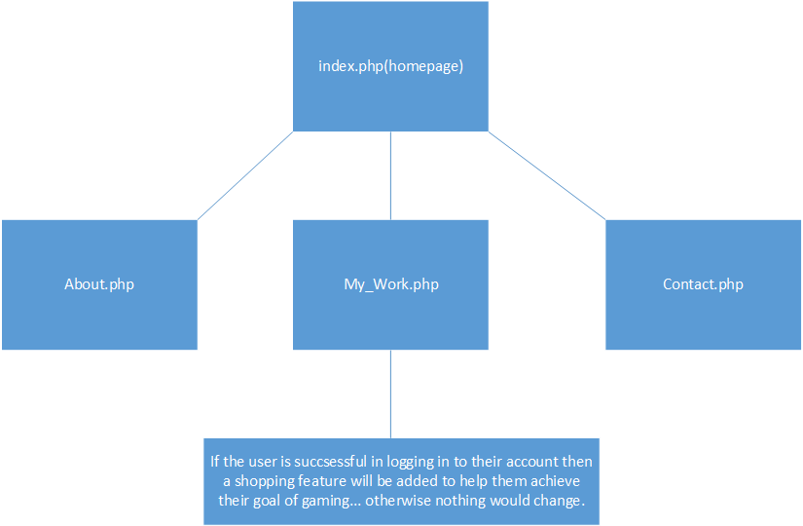

1. Database Plan: We use only one database on the school server.

Users table for UserAccount

| Field Name | Properties |
| --- | --- |
| UserID | INT(25) NOT NULL AUTO_INCREMENT PRIMARY KEY |
| Username | VARCHAR(65) NOT NULL |
| Password | VARCHAR(32) NOT NULL |
| EmailAddress | VARCHAR(255) NOT NULL |

‘Catalog’ table for buying games

| Field Name | Properties |
| --- | --- |
| Item_id | INT(25) NOT NULL AUTO_INCREMENT PRIMARY KEY |
| description | VARCHAR(65) NOT NULL |
| price | decimal(8, 2) NOT NULL |

Will use base.php to connect the databases

1. PHP plan

1) Basic 4 web pages (index.php, About.php, My_Work.php, Contact.php)

2) Register and login: I will add UserAccout business logic for login process. Anyone can register and login.

3) Member only page: My_work.php will have member only area so that only logged in members will see Shopping Cart.

4) Administrator can modify items for the shopping list.

1. Design drawling

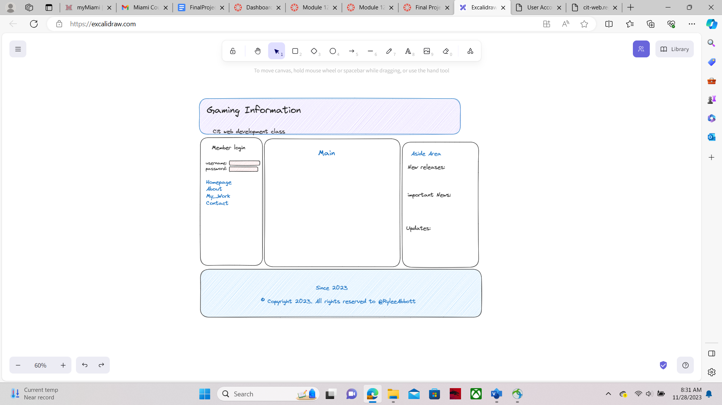

1. Other Plans:

CSS Plans:

I plan to use two CSS files they are “responsiveStyle.css” and “bannerStyle.css”. responsiveStyle is for overall program while banner is only for the banner.