Final Project – Web Application Development

Ali Al Mafrachi
Miami University Regionals
CIT273 H A
Dr. Dawar
May 02, 2025

- Topic/Theme: Online Event Registration System.
- Description: This website will allow users to register for various events. Users can sign up for events, view available events, and manage their registration. Administrators will have the ability to create, read, update, and delete event entries.
- User Features:
- Users can view events, register for them, and view their registration history.
- Registered users can log in and manage their registration (edit or cancel).
- Admin Features:
- Admin can create, edit, and delete events from the system.
- Admin can view all registered users for each event.
- Website Map & PHP Plan:
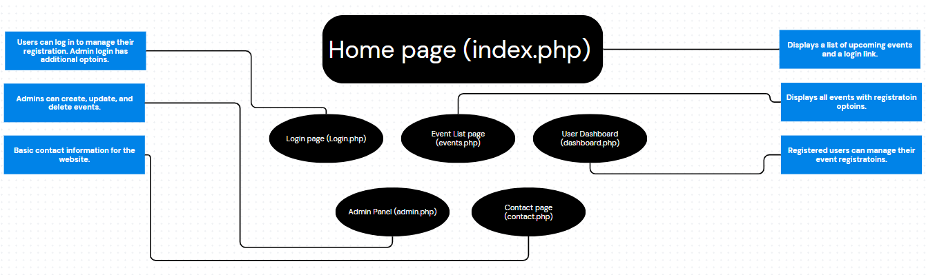

- Database plan:
- Users Table
Field name | properties
UserID | INT(25) NOT NULL AUTO_INCREMENT PRIMARY KEY
Username | VARCHAR(65) NOT NULL
Password | VARCHAR(32) NOT NULL
EmailAddress | VARCHAR(255) NOT NULL

- Events Table
Field name | properties
EventID | INT(25) NOT NULL AUTO_INCREMENT PRIMARY KEY
EventName | VARCHAR(100) NOT NULL
EventDate | DATE
EventLocatoin | VARCHAR(255) NOT NULL

Descriptoin | TEXT

- Registrations Table
Field name | properties
RegistrationID | INT(25) NOT NULL AUTO_INCREMENT PRIMARY KEY
UserID | INT(25) NOT NULL
EventID | INT(25) NOT NULL
RegistrationDate | DATE

- Form Plan:
For event registration, I will use a form to capture user data. The registration form will be presented on “events.php.” It will include fields like:
- User Name (auto-filled if logged in)
- Event Name (dropdown of available events)
- Registration Date (auto-generated)
- Other Plans:
- Style.css: Styling for the website, including layout and responsive design.
- Form.css: Specific styling for forms and buttons.
- Future Plan & Changes:
This plan outlines the expected structure and features of the project. However, I may adjust certain aspects, such as the user interface design, code, or the scope of user permissions.

