Dayton Brown-Limjuco
CIT 273
- Ping
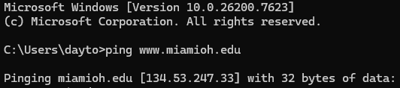

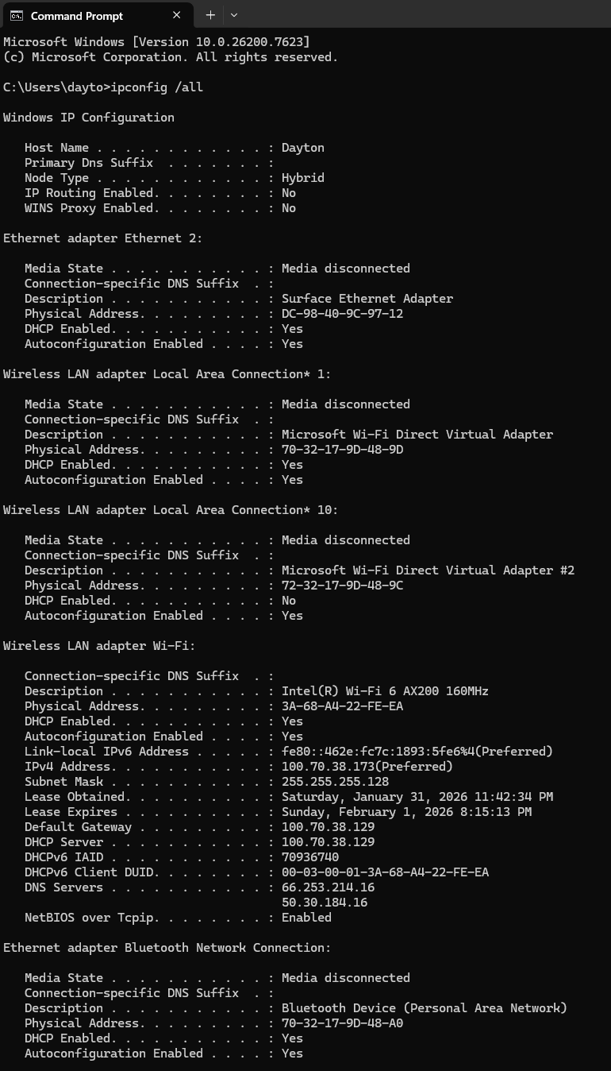
- Computer IP Address

Host Name: Dayton
• Primary DNS suffix: N/A
• Physical Address(MAC address): 70-32-17-9D-48-9D
• Host Computer ip v6: N/A
• Host Computer ip v4: N/A
• Subnet Mask: 255.255.255.128
• Default Gate way ip(v4): 100.70.38.129
• DHCP server ip(v4): 100.70.38.129
• DNS server ip(v4): 66.253.214.16

- IP Address for miamioh.edu
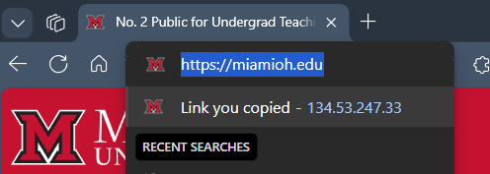

4. nslookup
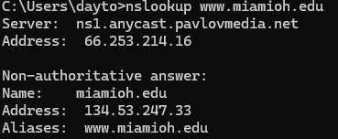

- View Source Code
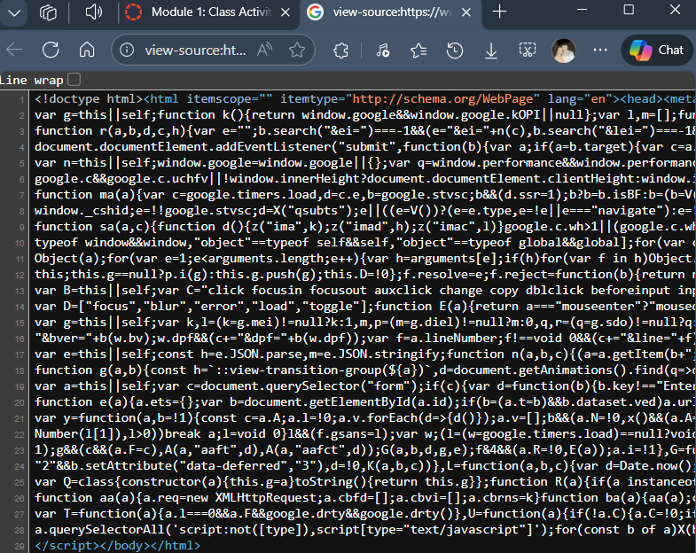

- Rex Swain’s Server
