Title of the Project: Fun Math and Games for 3rd Graders
Target Audience:
- 3rd grade students (ages 8–9)
- Elementary school students who want interactive learning activities
Purpose of the Website:
- Provide fun, educational content for children
- Teach math concepts with interactive exercises, games, videos, and music
- Offer a safe and engaging learning environment
Site Map (Visual):
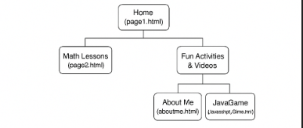
Instructions:
- Header/banner placement with image and text
- Navigation menu placement
- Main content area layout
- Sidebar/aside for tips, links, or media
- Footer placement
- Indicate where image, video, music, and Java Game link will appear
CSS & Design Notes:
- Use one main CSS file for header, nav, aside, footer
- Optional additional CSS for header/banner styling
- Make the site responsive (works on desktop and mobile)
- Use HTML5 semantic tags: , , , , , ,
Other Information:
- Your name and ID: Abishek Chhetri
- All pages will be created in Notepad++ as .html files
- Media: include at least one image, one video, and one music/audio file
- JavaScript Game will be linked from the site

