- Topic/Theme: AdoptionPetAccount

- Description: this website will be a pet adoption website where users can create accounts, browse available pets up for adoption, submit a form for adoption, and see information on application status. Users will be able to filter cats by breed, age, and personality. The Administrator can manipulate item table. There will be main pages (index.php, AdoptionForm.php, AdoptionCatalog.php, AdminDashboard.php, and Contact.php)
- Only “admin” user can C.R.U.D items from a table. Admin can approve or reject applications
- All members should register and login to submit adoption forms for cats from “Adoption_Form.php”

- Web Site Map
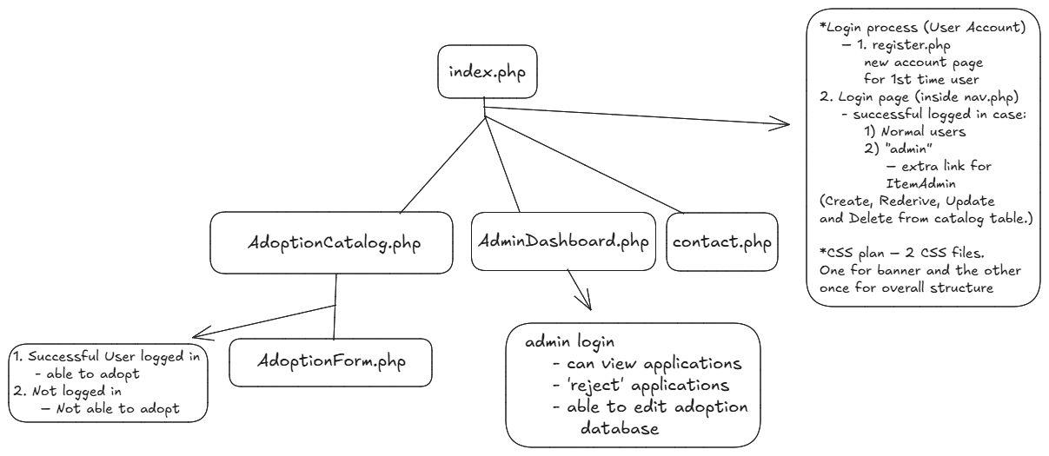
- Database Plan: only going to use on database on school server
- Tables will be created on the same database
- ‘users’ table for UserAccount
Field Name | Properties
userID | INT(25) NOT NULL AUTO_INCREMENT PRIMARY KEY
username | VARCHAR(65) NOT NULL
password | VARCHAR(32) NOT NULL
firstName | VARCHAR(25) NOT NULL
lastName | VARCHAR(25) NOT NULL
phoneNumber | VARCHAR(15) NOT NULL
address | VARCHAR(45) NOT NULL
email | VARCHAR(35) NOT NULL

- ‘catalog’ table for PetAdoption
Field Name | Properties
catID | INT(25) NOT NULL AUTO_INCREMENT PRIMARY KEY
catAge | INT(25) NOT NULL
catPersonality | VARCHAR(25) NOT NULL
catBreed | VARCHAR(35) NOT NULL
catDescription | VARCHAR(255) NOT NULL
petImage

- ‘application’ table for PetAdoptionApplications
Field Name | Properties
Application_ID | INT(25) NOT NULL AUTO_INCREMENT PRIMARY KEY
userID | VARCHAR(255) NOT NULL
housingType | ENUM('Rent', 'Own') NOT NULL
otherPets | INT(25) NOT NULL
experienceWithPets | ENUM('First-time Owner', 'Experienced Owner') NOT NULL
lifestyle | VARCHAR(255) NOT NULL
applicationDate | DATETIME NOT NULL DEFAULT CURRENT_TIMESTAMP
catID | INT(25) NOT NULL AUTO_INCREMENT
agreementTerms | BOOLEAN NOT NULL DEFAULT 0

- ‘base.php’ and ‘imageBase.php’ will be used to connect the database

- PHP Plan
- Basic 4 web pages (index.php, Adoption_form.php, AdoptionCatalog.php, and Admin_Dashboard.php)
- UserAccount business logic will be added for the login process. Anyone will be able to register and login.
- Adoption applications are only available to registered users
- AdoptionCatalog will have a members only area where they can check the status of their application
- Administrator can modify pets for adoption and reject or accept applications

- Form Plan
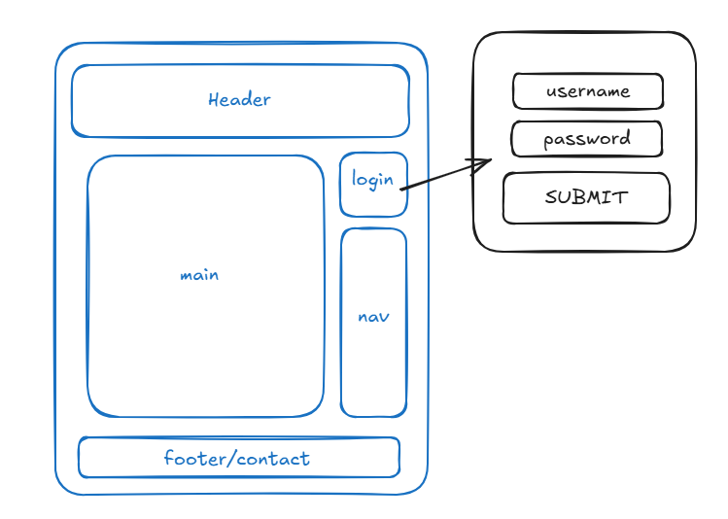

- Others Plan:
I will use Style.css for main structure
I will use banner.css for banner portion format only.
