#### **Title of the Project**

Fun Learning for Kids: 3rd Grade

**Target Audience**

3rd Grade Students - The website is designed specifically for children in the 3rd grade, providing engaging and interactive math content suitable for their learning level.

#### 

#### **Purpose of the Website**

The purpose of this website is to create a fun and interactive platform for 3rd grade students to enhance their math skills through games, videos, and engaging activities. It aims to make learning enjoyable and accessible, encouraging students to practice math in a playful environment.

#### **Site Map (Visual Below)**

* Home
  + Introduction to 3rd Grade Math
  + Links to Activities
* Page 1: Addition and Subtraction Games
  + Interactive games and videos for practicing addition and subtraction
* Page 2: Multiplication and Division Activities
  + Interactive games and videos for multiplication and division
* About Me
  + Information about the creator and the purpose of the website
* JavaScript Game
* Link to the Java game created in Assignment 6-2

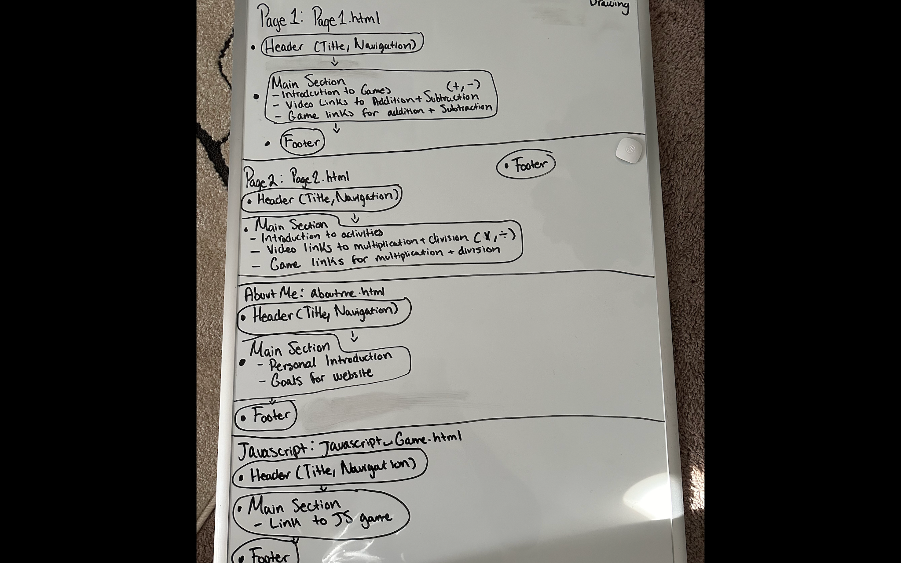

#### 

#### 

#### 

#### 

#### 

#### 

#### 

#### 

#### 

#### 

#### 

#### 

#### 

#### 

#### 

#### 

#### 

#### 

#### 

#### 

#### **Wireframe**

* Page 1: Addition and Subtraction Games
  + Header: Title and Navigation
  + Main Section: Links to games and learning videos
  + Footer: Contact information and copyright
* Page 2: Multiplication and Division Activities
  + Header: Title and Navigation
  + Main Section: Links to games and learning videos
  + Footer: Contact information and copyright
* About Me
  + Header: Title and Navigation
  + Main Section: Personal introduction, goals for the website
  + Footer: Contact information and copyright