Andrew Gartner

Parth Thakor

Joey Chow

Junior Nyamusa

THE DATABASE BOOK

Contents

Table of Contents 1

Executive Summary 2

Management report 4

User Guide 5

Normalization Process 6

Entity Relationship Diagram 7

Relational Schema Diagram 9

User Interface 10

Database tables 11

Data Dictionary 12

Forms 13

Queries 14

Reports 15

# Executive Summary

My work that I’ve done for the organization is that I’ve created a couple of database tables in MySQL Workbench, typed in reflections for past projects, and worked on attributes referring to the Normalization process. I also co-worked with three other people in my team so that I wouldn’t work on the projects alone and the tasks can be split up.

# Management report

The first thing that got done from my projects is that I created database tables in MySQL Workbench. I started off by creating a sequence for my tables and then also gave it a meaningful name. Then, I created the structure of the tables by adding in attributes, selecting VARCHAR () for data type, and selecting which attributes are a primary key and if it’s considered unique. After I created the database tables, I then entered five rows of data for each of the tables that I’ve created.

The second thing that got done for my projects is that I typed in reflections from past assignments. Every time my team starts on a new project, I’m usually the one that likes to type in a reflective summary of what our team did in past assignments and see what mistakes we made and learned from. I also explain in my reflective summary of what we’re going to be doing in our current project. At the end of the project, I would recap of what we as a group think we did good and bad of our work on the project.

The last thing that got done for my projects is that I worked on attributes that reflected on the Normalization Process. For instance, I would work on some of the things that the process wants like I would work on implementing the attributes into the 1NF and 2NF tables and somebody else in my group would work on the 3NF table and describing the entity and relationship names for the attributes. With me splitting the work with another groupmate, it gives the other person something to do rather than doing the whole work to myself.

What next steps that the subsequent project team might do is that they may follow the project life cycle. The Project Life Cycle has five stages that includes initiating, planning, executing, monitoring/controlling, and closing. These phases help the project team complete work more smoothly and make responsible decisions. The five phases will make up the path that takes their project from the beginning all the way to the end.

# User Guide

1) Bar Chart:

Chart Representation: Displays a bar chart representing data related to the entered search term (customer, electrician, etc.).

Details Button: Click to view detailed information corresponding to the selected bar on the chart.

2) Search Bar:

Enter a customer name, electrician name, or customer ID (CID) into the search bar. You can search for specific customers, electricians, or customer IDs.

3) Search Button:

Click the "Search" button to initiate the search.

4) Results Displayed:

The results of your search will be displayed in table format. The table may include relevant details such as customer name, electrician name, customer ID, etc.

5) Interacting with Results:

Click on any row in the table to view more details or perform additional actions.

# Normalization Process

2(a). 1st Normal Form Table

{cid, cfname, clname, cadd, cstreet, ccity, cstate, czip, cphone, sdate, eid, efname, elname, ephone, elevel, erate, shours, pid, pname, pprice, pqty}

2(b). 2nd Normal Form Tables

{pid, pname, pprice}

{cid, cfname, clname, cadd, cstreet, ccity, cstate, czip, cphone}

{eid, efname, elname, ephone, elevel, erate}

{cid, sdate, eid, shours}

{cid, pid, sdate, pqty}

2(c). 3rd Normal Form Tables

{pid, pname, pprice}

{cid, cfname, clname, cadd, cstreet, ccity, cstate, czip, cphone}

{eid, efname, elname, ephone, elevel}

{elevel, erate}

{cid, sdate, eid, shours}

{cid, pid, sdate, pqty}

2(d). Name the tables and identify each table as an Entity or Composite Relationship.

{pid, pname, pprice} E PARTS

{cid, cfname, clname, cadd, cstreet, ccity, cstate, czip, cphone} E CUSTOMER

{eid, efname, elname, ephone, elevel} E ELECTRICIAN

{elevel, erate} E LEVEL

{cid, sdate, eid, shours} R Service_call

{cid, pid, sdate, pqty} R Part_usage

# Entity Relationship Diagram

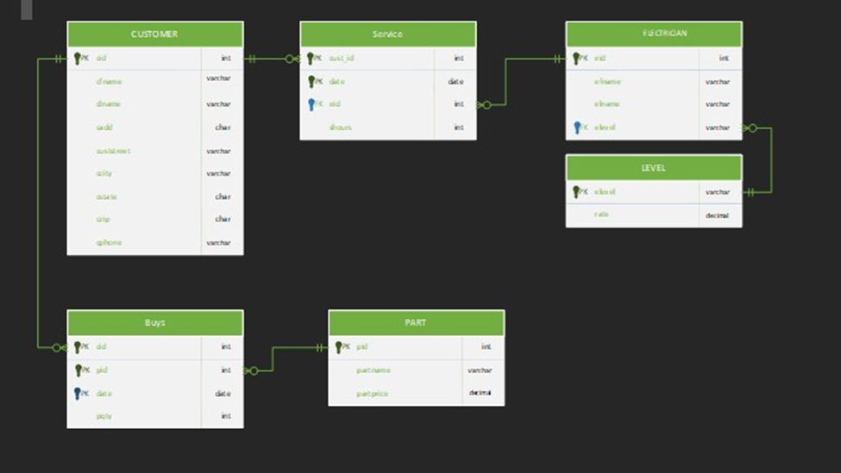

# Relational Schema Diagram

# User Interface

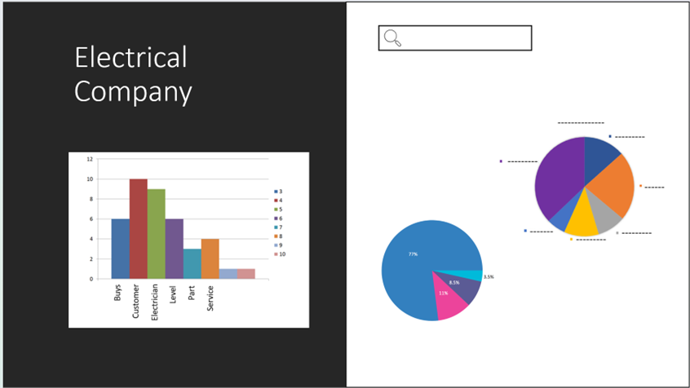

# Database tables

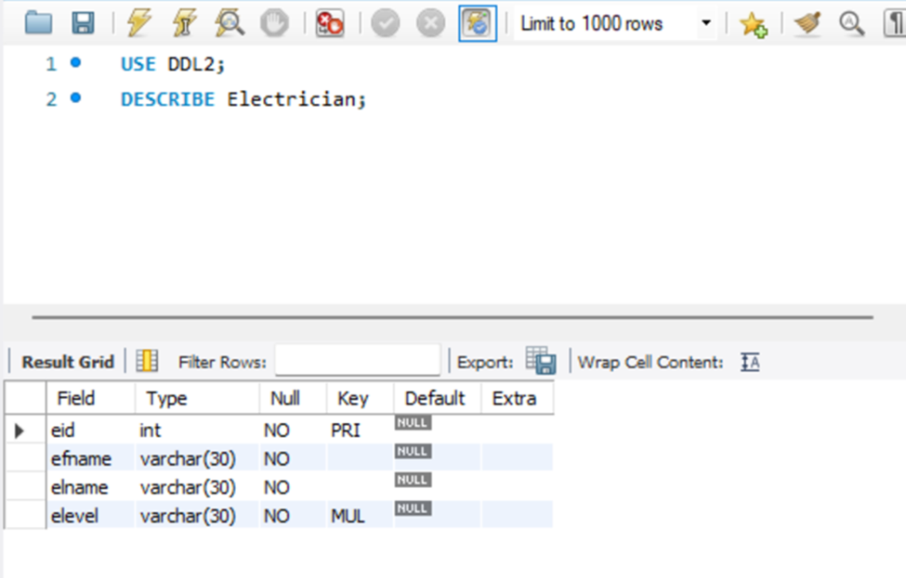

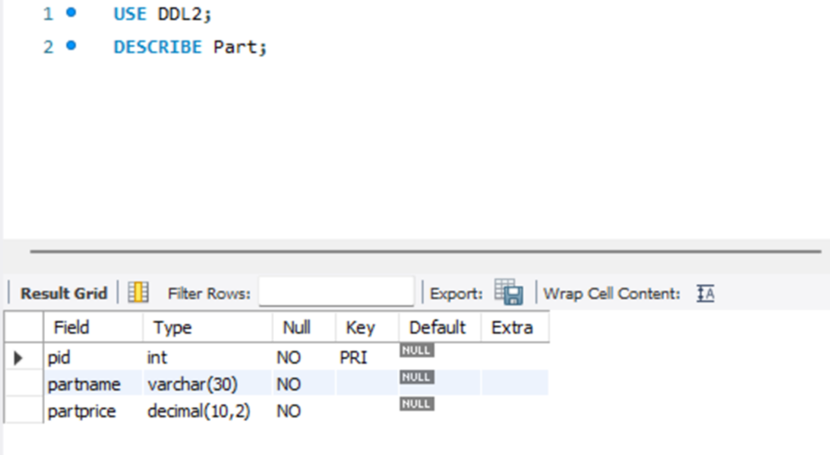

# Data Dictionary

|  |  |  |  |  |  |  |  |
| --- | --- | --- | --- | --- | --- | --- | --- |
| Attribute Name | Attribute data type | Attribute length | Attribute format | Tables | Constraints on the attribute | Description | Example |
| pid | INT | 3 | String | Buys/PART | Primary key | Part identification number | P3421067 |
| pname | VARCHAR | 5 | String | Part | Not null | Part name | Crane Steel |
| pprice | DECIMAL | 6 | Numeric | Part | Not null | Part price | $32,562 |
| cid | INT | 3 | String | Buys/CUSTOMER/Service | Primary key | Customer identification number | C307573 |
| cfname | VARCHAR | 6 | String | CUSTOMER | Not null | Customer first name | Randy |
| clname | VARCHAR | 6 | String | CUSTOMER | Not null | Customer last name | Smith |
| cadd | VARCHAR | 4 | Numeric | CUSTOMER | Not null | Customer address | 1633 |
| cstreet | VARCHAR | 7 | String | CUSTOMER | Not null | Customer street | Main St. |
| ccity | VARCHAR | 5 | String | CUSTOMER | Not null | Customer city | Niagara Falls |
| cstate | CHAR | 6 | String | CUSTOMER | Not null | Customer state | NY |
| czip | CHAR | 4 | Numeric | CUSTOMER | Not null | Customer zip | L2E |
| cphone | VARCHAR | 6 | Numeric | CUSTOMER | Not null | Customer phone | 905-329-1174 |
| sdate | DATE | 5 | Numeric | Buys/Service | Primary key | Service date | 5/23/2022 |
| pqty | INT | 4 | String | Buys | Not null | Part Quantity | 1 |
| eid | INT | 3 | String | Service/ELECTRICIAN | Primary key | Electrician identification number | E5749857 |
| shours | INT | 6 | String | Service | Not null | Service hours | 6am - 6pm |
| efname | VARCHAR | 6 | String | ELECTRICIAN | Not null | Electrician first name | Fred |
| elname | VARCHAR | 6 | String | ELECTRICIAN | Not null | Electrician last name | Grapher |
| ephone | VARCHAR | 6 | Numeric | ELECTRICIAN | Not null | Electrician phone | 905-956-0043 |
| elevel | VARCHAR | 6 | String | SKILL/ELECTRICIAN | Primary key | Skill level | Intermediate |
| erate | DECIMAL | 5 | String | SKILL | Not null | Skill rate | Proficient |

# Forms

# Queries

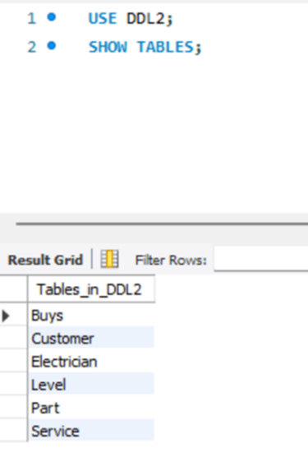 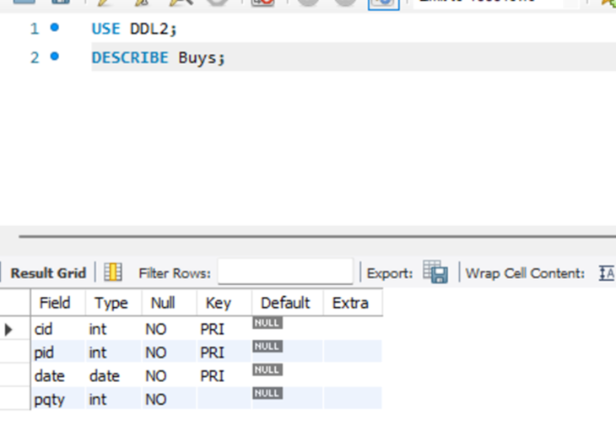 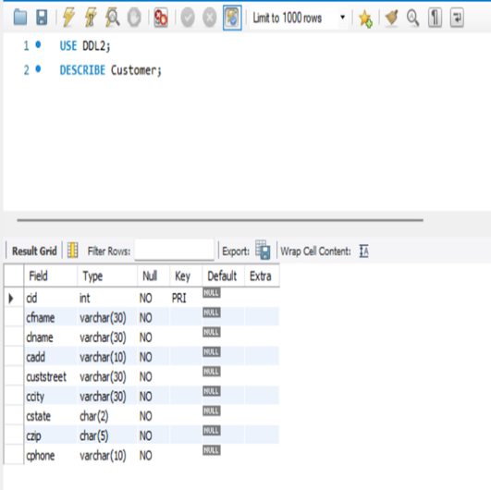

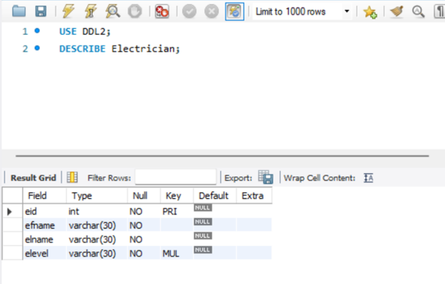 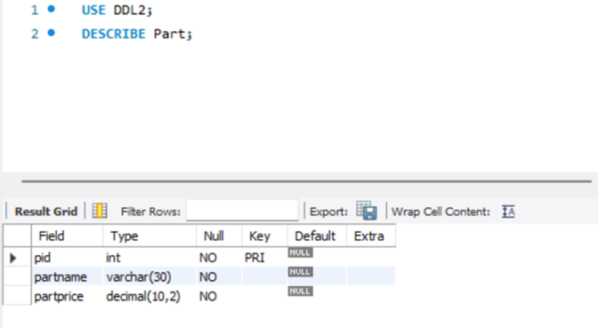 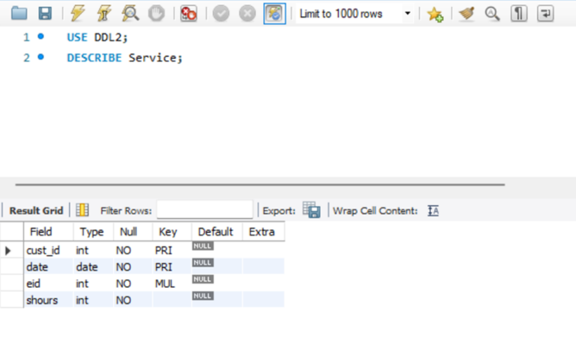 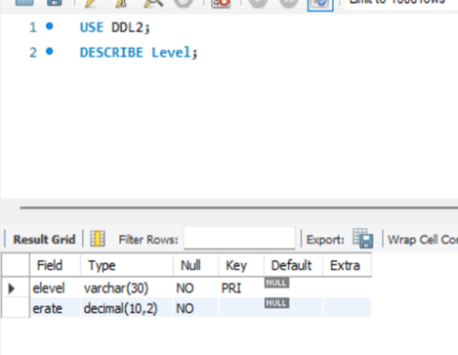

# Reports

