Andrew Gartner
12/4/2023

The database design that I selected is the Normalization Grey’s Rooming House Assignment. The reason why I chose this database assignment is because there’s a lot of attributes that make more sense to me to make good queries. The attribute names aren’t weird, so it makes my assignment of doing queries a bit easier for me since the names are easy to understand. There are also five tables provided, so that gives me more variety when I create my queries.
“SHOW” query
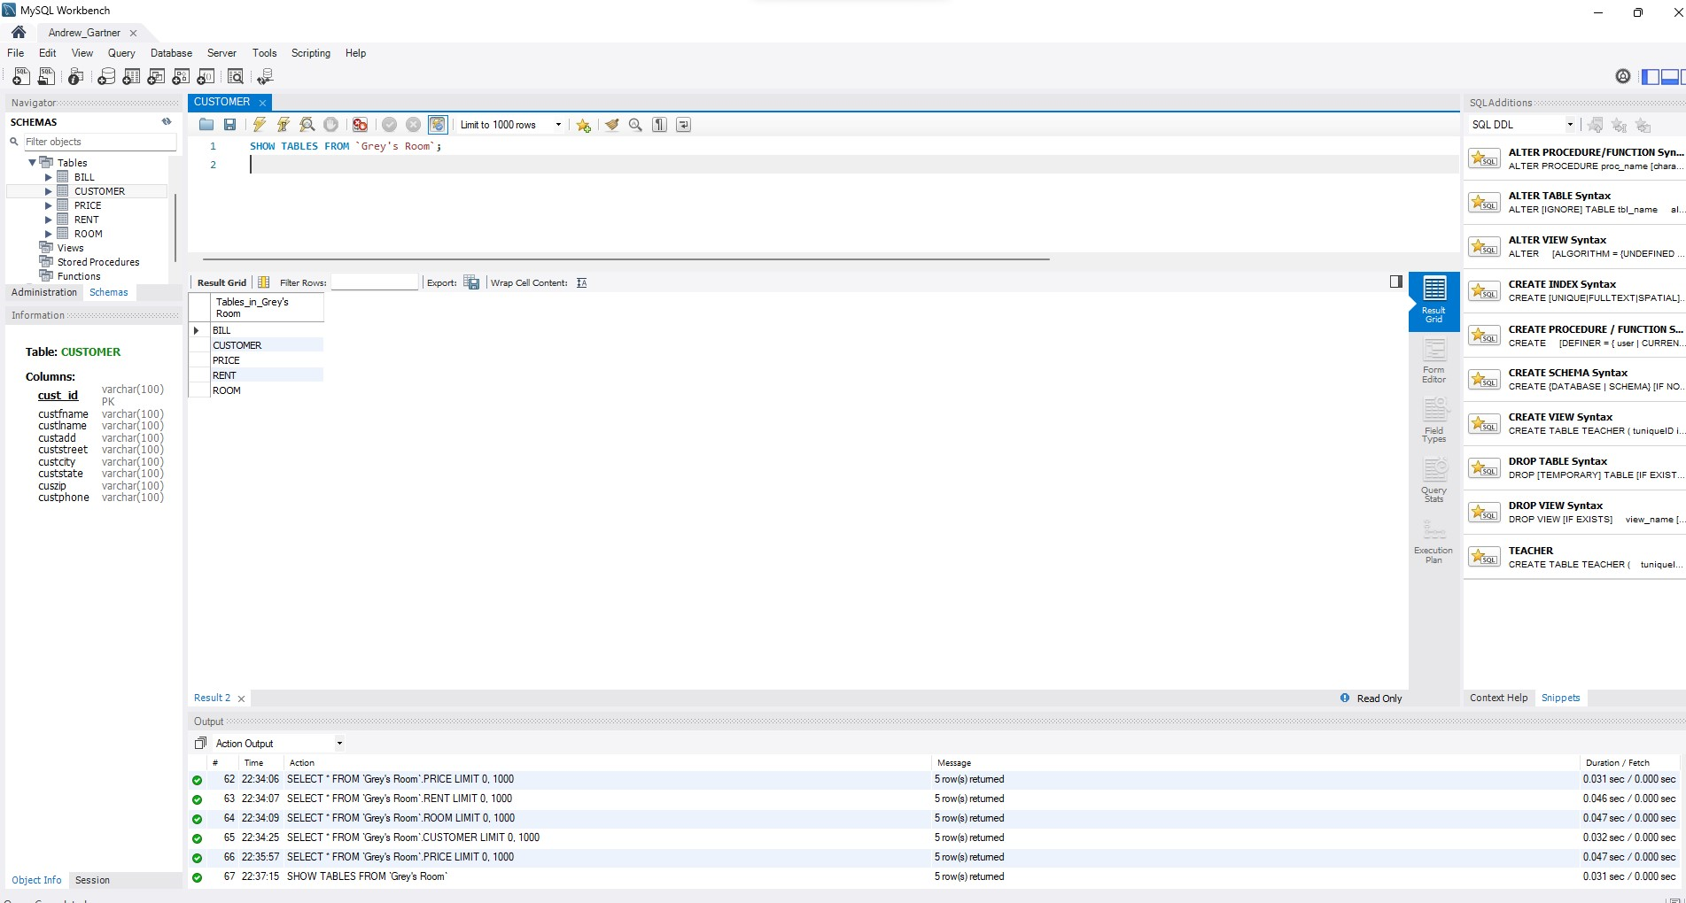
Select *From for Customer
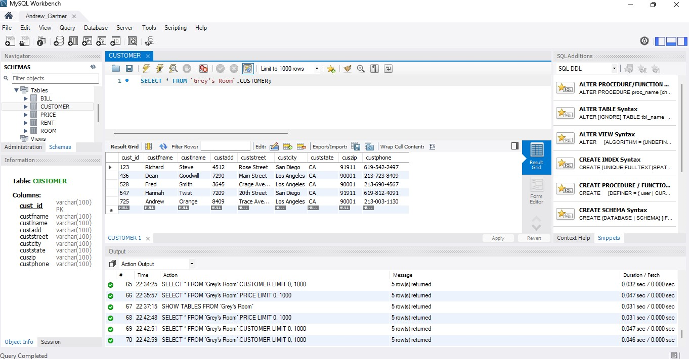
Select *From for Price
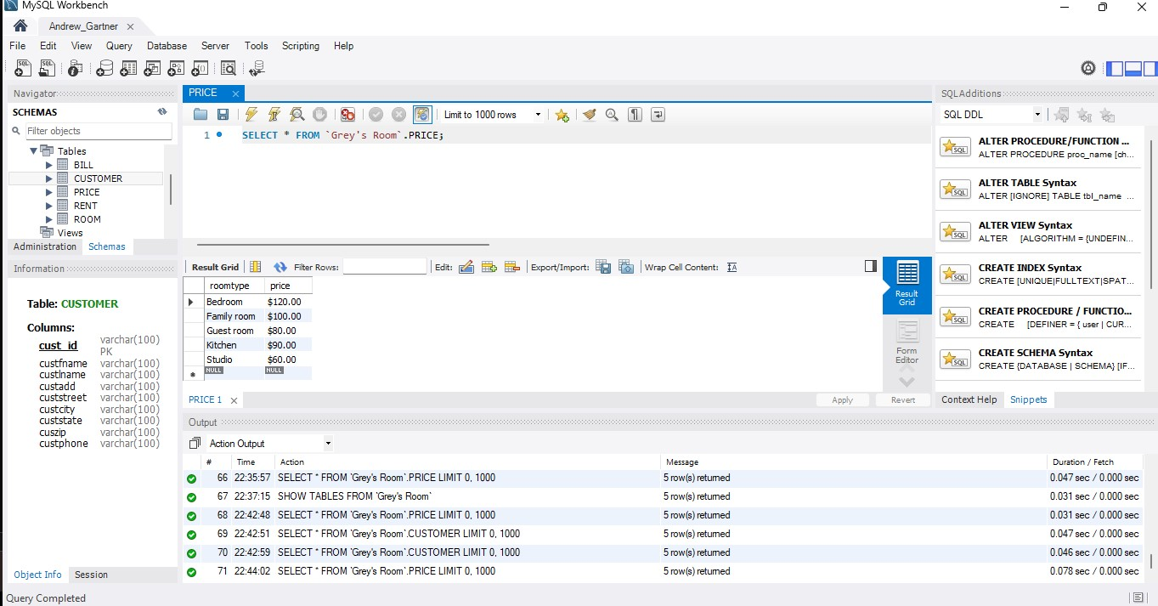
Select *From for Bill
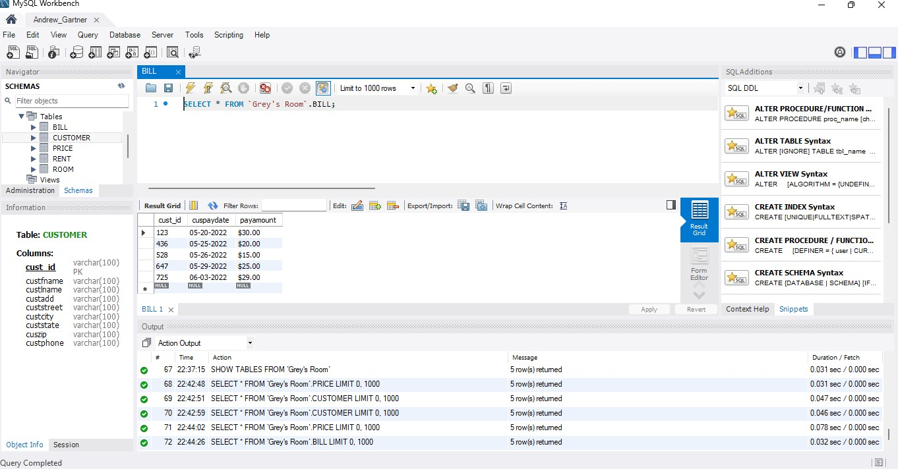
Select *From for Rent
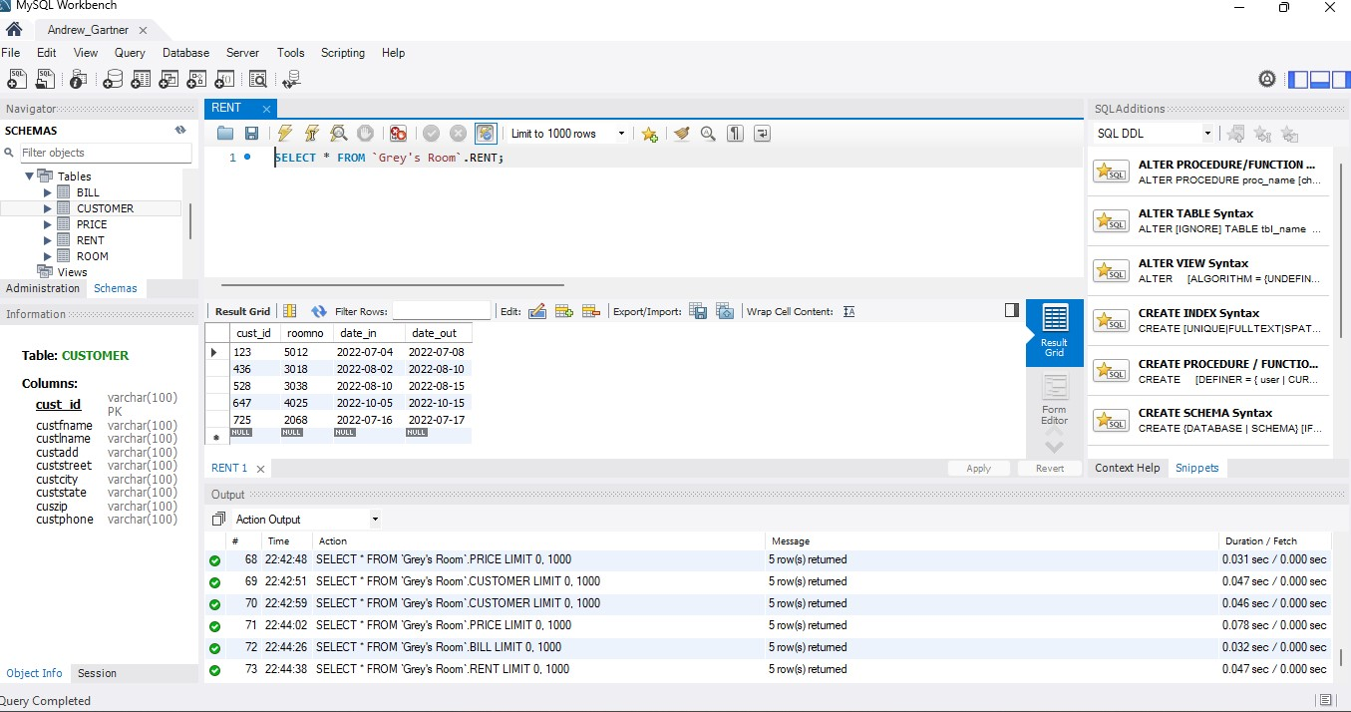
Select *From for Room
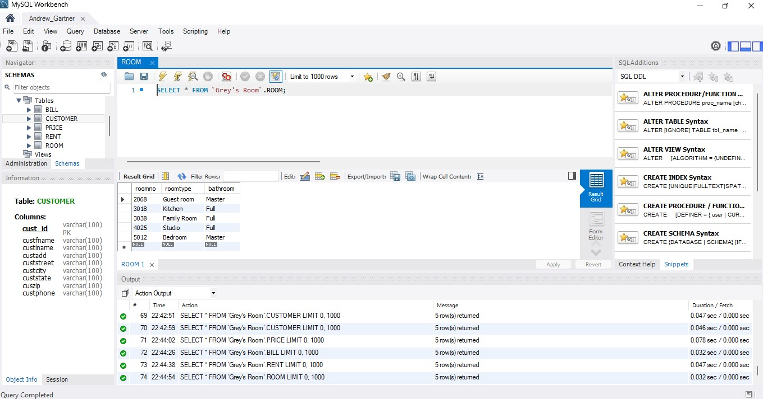
Query 1:
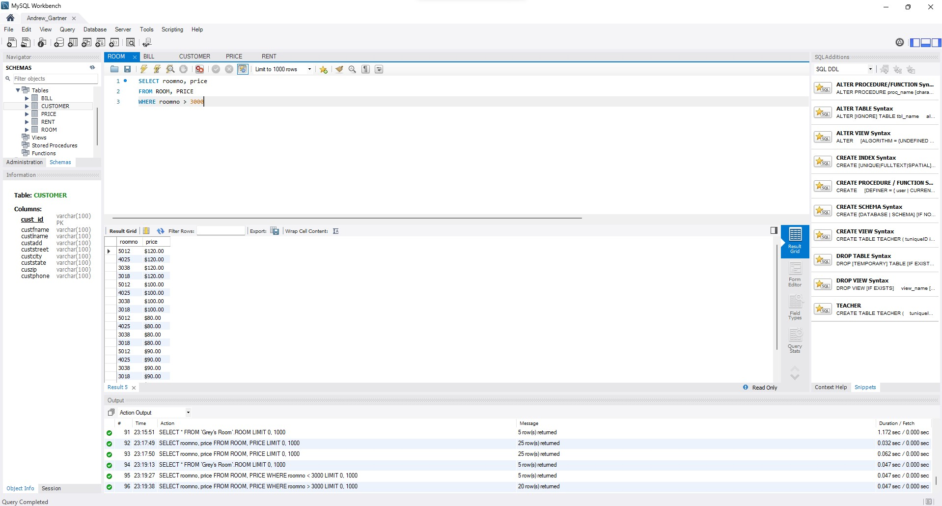
The reason why I chose the SELECT .. WHERE query is that it felt like an easy query to work around with. With the select statement, I can select different attributes and it can be any. And with the where statement, I can select the range from greater than, less than, or equal to. The from statement must be chosen from the tables made.
Query 2:
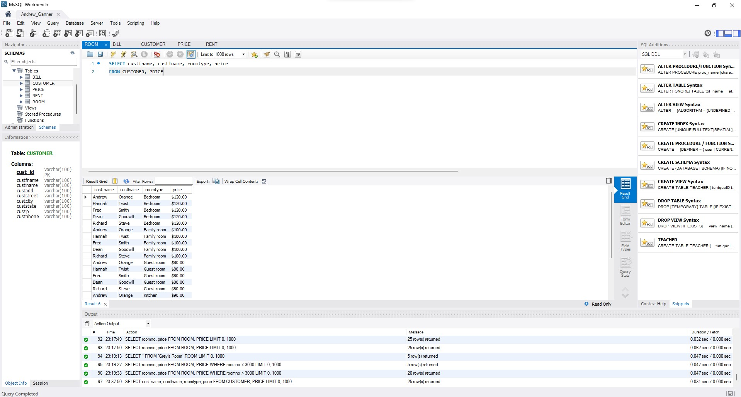
The reason why I chose the SELECT .. FROM statement is that it’s an easy query and I don’t need to do a whole lot. I can just select different attributes for the select statement and I can select the proper tables for the from statement.

