Andrew Gartner

Let’s say that a student needs to buy a textbook for their Architecture class and it’s only available online. There are multiple book websites out there for that student to search for the correct textbook, but what if those websites either don’t have the right one or if they’re not available? At that point, the student would need to go through Amazon to buy the correct textbook. For that student to find his/her correct textbook, they will first need to locate the search box. It should be easy to find where the student can locate Amazon’s search box (which is located horizontally on top of the Amazon website).

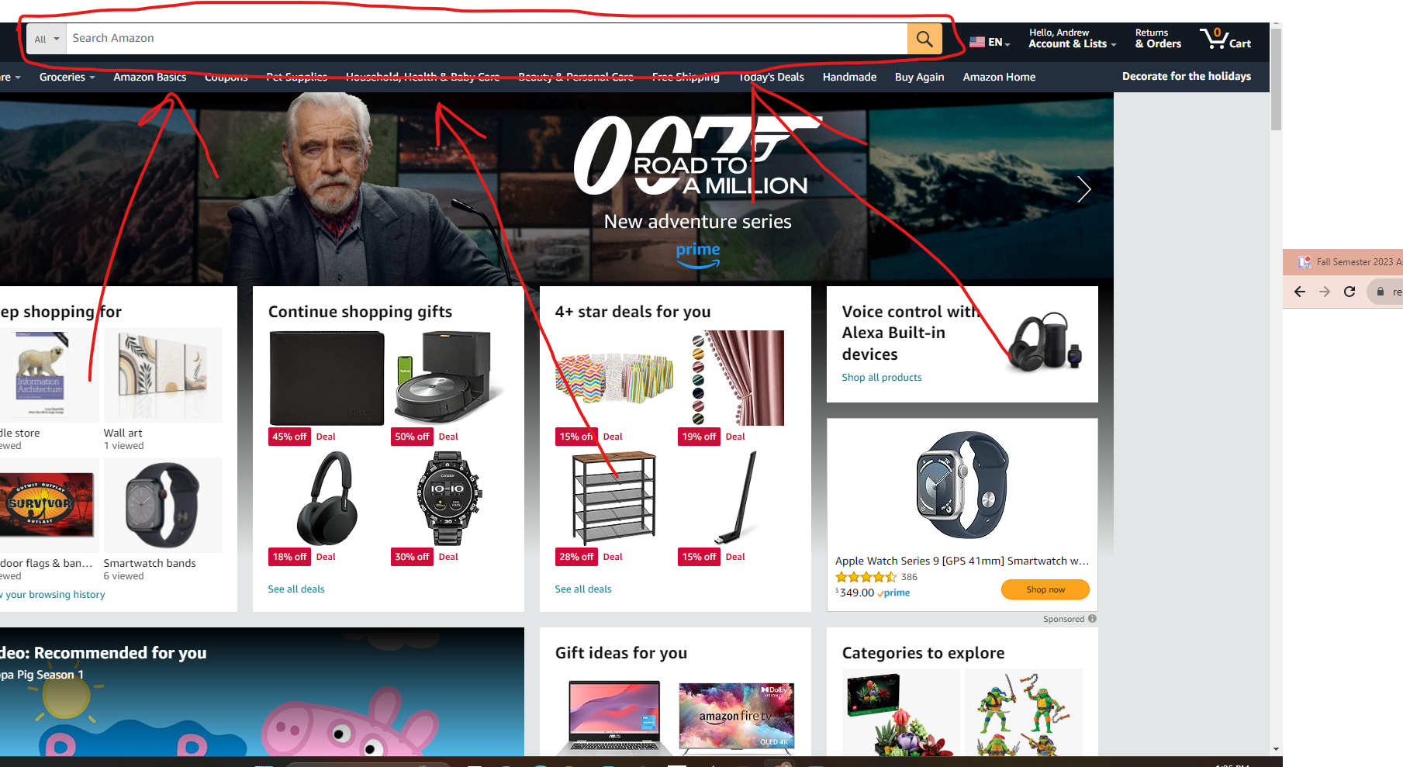

In the search box, the student will then type in what textbook they’re looking for. For this instance, they’ll type in the correct textbook for what they need for their Architecture class. After they type the textbook name in the search box, they’ll then either click on the yellow box with the search icon or press Enter on the keyboard to take them to a list of Architecture textbooks available. From there, the student should be able to find their correct Architecture textbook.



The student will start finding their correct Architecture textbook. For instance, they’ll need to buy a textbook named *“Information Architecture: For the Web and Beyond”*. From there, the student will find that named textbook and once found, they’ll click on the textbook cover to send them to a page that shows them the cover of that book. Price information is also provided before the student clicks on the cover so that they know the price ahead of time. After the student clicks on the cover, it takes them to the cover page. From there, the student can either click on the cover of the book or the buy icon if they want to buy their textbook. There are also price ranges for a Kindle version, Audiobook, and Paperback of the textbook, so that gives the student more options of what type of textbook they prefer. They’re also given the option if they want to either rent the book or just buy it fully.

The student will find what best option fits best for them. For instance, the student wants to buy a paperback copy of the textbook and prefers it delivered to their house. In this case, they would need to click on the delivery option, select the quantity option, then click on the “Buy Now” button. If the student wants to continue shopping, then they can click on the “Add to Cart” button. Once they’re ready to buy the book, they’ll need to type in their personal information and card information. After both information is typed in, the student can now press “Place your order”.

