Mini Project 3

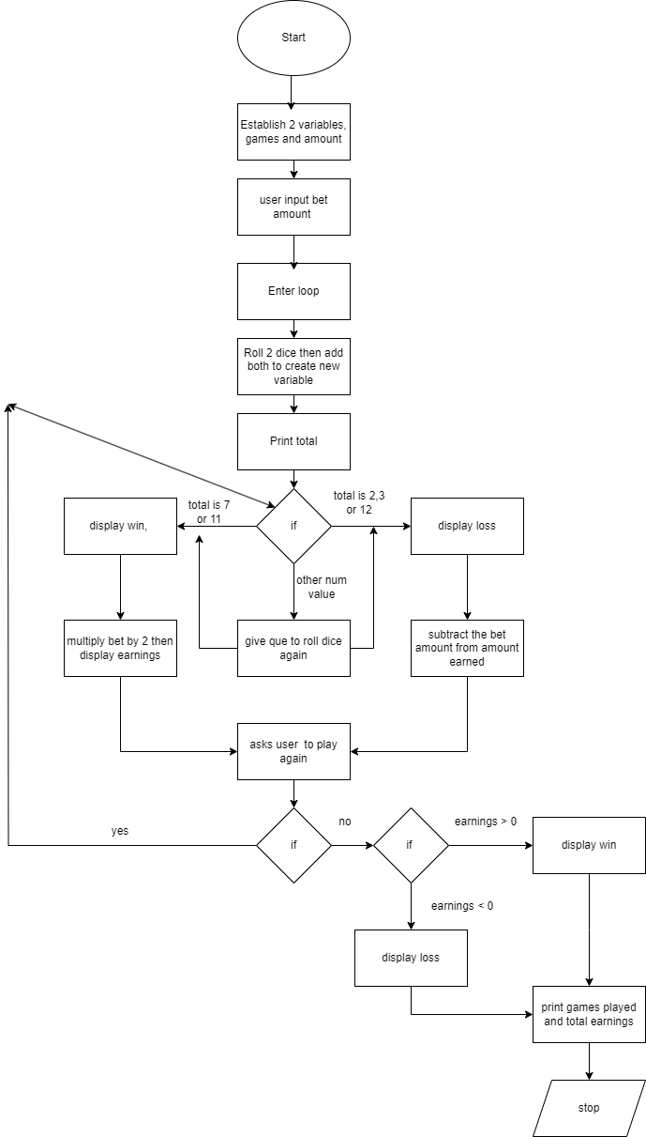

Pseudocode

1. Make 2 variables for games and earnings.
2. User input bet amount
3. Roll 2 dice then add them together.
4. Display the dice added.
5. If dice 7 or 11 then display win and multiply bet by 2
6. If dice is 2,3 or 12 then loss and subtract bet amount
7. If any other number roll dices again
8. Add 1 to the number of games.
9. Ask the user to play again, in the form of input.
10. If agree run through loop again
11. If not, then display how many games got played and then how much they won.
12. If earnings were greater than 0 then they won otherwise lost

Testing

