# Mini Project 3 – Craps Game

**Diagram**

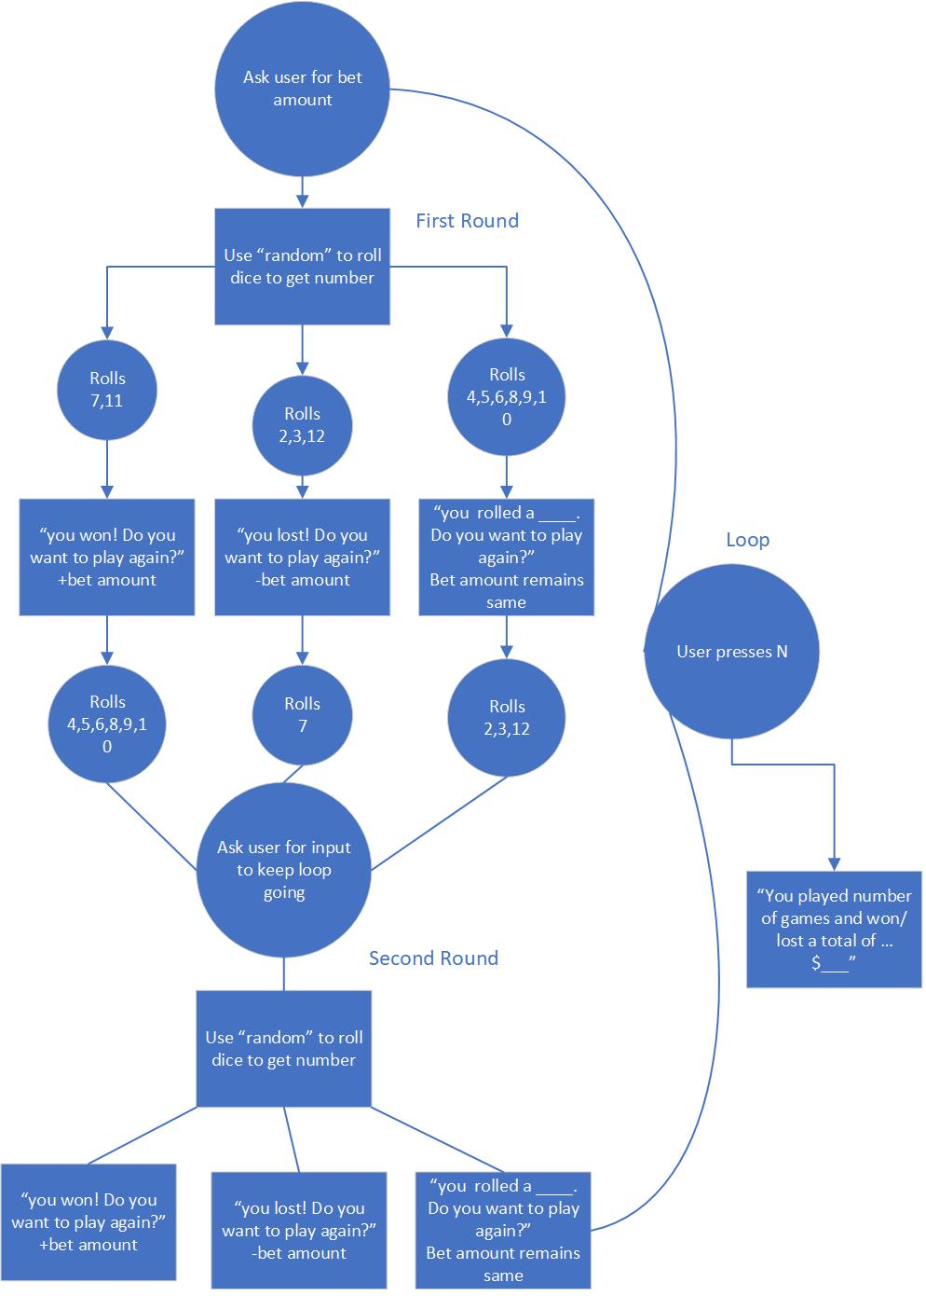

**Pseudo Code**

Import Random module

Create a dice rolling function

Create game function

Counter for balance =0

Counter for rounds = 0

Try Loop:

Input for bet amount

Counter for round+1

Round 1 = Call roll dice function

If dice == 7 or 11

Balance + bet

Print(you rolled a {dice total} and won ${bet}!)

If dice==2, 3,12

Balance-bet

Print(you rolled a {dice total} and lost ${bet}!)

Else round 2:

Point = dice total from last round

Print(Your point is {point}!)

Loop:

Create input

If input==N print(you won {total balance} and you played {total rounds}!)

Break

Roll dice again in loop

If new roll == 7

Balance - bet

Print(you rolled a {new roll} and lost {bet}!)

If new roll==point

Balance + bet

Print(you rolled a {new roll} and won{bet}

If new roll is anything else

Print(you rolled a {new roll}, roll again!

Main loop with craps_game()

**Program Run Tests**

1.First roll not a 7 or 11

2. First roll as 7 or 11

3. Second roll that loops

4. N in first round

5. N in second round

**My program runs as expected and why?**

My program runs a simple craps game that takes a bet which in turn can be won or lost based on the business rules defined. There was no starting bet defined so I have users starting at 0. Two rounds are given, and N allows the user to exit the defined loops and view metrics about the user’s session with total of money won/lost and rounds played in both rounds.

The only thing missing from my program is that I do not require the user to type Y for every round, only enter and N if they choose to exit. However, if the user does not enter a bet at the start of the program it will simply display the metrics and prompt you to enter a bet again. Suggestions as to how I could improve my code to be more efficient would be wonderful!