Andrew Gartner

Summary Table
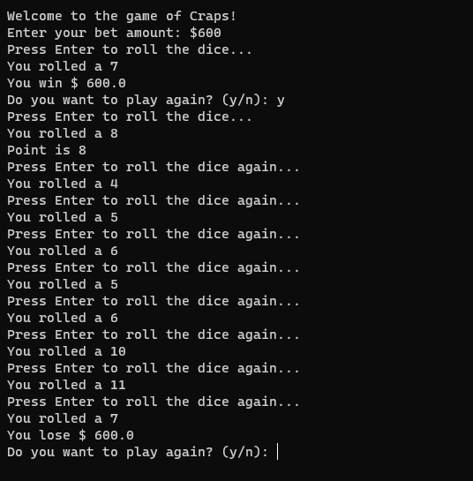
I’m fifty and fifty about my program that should run as expected. The reason why I think my program is correctly programmed, but at the same time is not that I did a lot of indenting in Visual Studio Code and the results more than likely don’t follow the rules as the tables says in Canvas. Plus, I hadn’t heard about the game “Craps”, so I just followed the flow with my code and saw what happened. I slightly believe that the program isn’t coded right to be in line with the game rules, but at least the game is functionally nicely with no errors.

