1/1/2023

Evan Gregory

Department of computer information technology

Miami University

Medical Website Title

Senior Capstone Project

CIT 468

Table of Contents

Executive Summary 1

Baseline Project Plan 1

Project Proposal 1

Line of Communication 1

Potential Improvements 1

Technology 2

Project Scope 2

Feasibility Study (Operational, Economic, Technical, Schedule) 3

Operational 3

Economic 3

Technical 3

Schedule 3

Legal and Ethical 4

Risk Assessment 4

Alternatives and Viability 4

Implementation 4

Prototyping Iterations Use subsections as necessary. 4

Testing Use subsections as necessary. 4

Maintenance Use subsections as necessary. 4

Acknowledgments 5

References 5

Appendix A Business Process Diagrams 6

Appendix B Work Breakdown Schedule 8

Appendix C Critical Status Reports 9

Appendix D Appropriate Screenshots as needed 10

Appendix D User Guide 11

Appendix E E/R Diagram 11

Appendix F User Stories [MoSCoW] 11

# Executive Summary

In this section, you must summarize your entire project. This section is designed to be short, think of it as an expanded project pitch. It should contain the business problem being solved, project objectives, important milestones, the value of the system and what the final product contains and does not contain. Typically, this section is done last as it should summarize what you have done, what future work should be done, limitations to the system, etc.

# Baseline Project Plan

In this section (can be and in general is 2 different sections, one for the initial requirements/analysis and one for the BPP), you should discuss your initial requirements and the basic design of your project. This section explains what you expected to complete and how. It includes a discussion of the project scope: user stories and your prioritization of these requirements. Include a discussion of your Business process diagrams. Include a risk assessment that includes any ethical considerations. project. Note the diagrams, etc. will be in the Appendix. Included here is a discussion with a reference to these diagrams.

## Project Proposal

### Line of Communication

The goal of this project is to implement a system that will allow a better flow of communication between patients and medical staff. Currently, electronic health records (EHRs) serve this purpose, but they are not always user friendly and can sometimes be lacking in the user experience department. The systems can feel archaic, and it is hard for the staff to implement changes that allow them to fully customize the experience for each patients’ unique needs.

### Potential Improvements

## 

Currently, in a lot of situations a patient will fill out a form with pen and paper when they enter a medical facility for an appointment or will have to answer a questionnaire in the examining room with a staff member. This system will allow these procedures to take place in the comfort of the patient’s home before they even step foot into the office. This will save valuable time for both the patients and the staff and can help ease the anxiety that may be experienced sitting in a cramped doctor’s office filling out medical forms.

### Technology

This project is built on HTML, PhP, and JavaScript. It also interfaces with a MySQL database to safely store user data. The technology used and implemented may need to change as the project continues, and limitations are discovered, but at this time there do not appear to be any roadblocks.

## Project Scope

The goal of the project is to create a working website that will allow a medical

staff to send their patients pre-visit forms that can be filled out in the comfort of their homes. Below is an overview of the project, for a more detailed timeline, please see Figure B.1 or Figure B.2 in the appendix.

The project will begin by creating simple webpages that will be improved upon on further iterations. The first pages that will be created will be: the home page, a registration page, and separate portals for patients and staff. The site will be linked to a SQL database that will be used to securely store client information.

Once these have been created, the biggest task will be started: creating the ability for the medical staff to create a customizable form that they can then send to their patients before the scheduled appointment. This system will be conducted either by email, or by an internal system, which is to be determined. Reminders may be sent by email or a SMS messaging system, which has also not been determined yet.

Each of these requirements are defined in the project timeline that is outlined in the appendix, but generally the first webpages will be completed in sprint 1, finished by September 15th. The implementation of the SQL integration will be done in sprint 2, finished by October 2nd. The form creation tool, which is the greatest task, will be done in sprint 3 and 4, finishing October 18th and November 8th, respectively.

## Feasibility Study (Operational, Economic, Technical, Schedule)

### Operational

There is currently a gap in-between medical care, and the implementation of technology. There are some facilities that use things like iPads to complete the collection of data for a patient before their appointment, but they are in use at the facility, rather then being done at the patient’s home. The system that is being proposed would eliminate the need for these forms, written or digital in-person versions, and allow the workflow process to improve exponentially.

### Economic

To scale the system to a large nationwide platform would be very expensive but would be feasible. Doing so would allow the system to reach many potential customers and would open revenue streams to allow continued growth. The more customers reached, the more the backend can be improved, adding stability and reliability, and thus increasing the reach even further.

### Technical

This system does not have any thing that makes it impossible to build currently. The only thing that will be a concern is the timeline constraint on the project, but the team feels that it will be possible to implement the base level project by the deadline. HTML, PhP, and Javascript all work together to provide the necessary tools required to create this system.

### Schedule

The biggest obstacle for this project is the deadline to finish in time. The team feels that a MMP is possible, but with the deadline it may not be as polished as they wish it to be. It is also important for the team to keep in mind that the deadline is not flexible and that the work must be completed on time. Each sprint has been detailed in the timeline that is posted in the appendix for reference.

### Legal and Ethical

Since the system is dealing with medical information, HIPPA considerations are important for US based clients. Those that may be using the system in the EU will also require the team to consider the GDPR. This means that security is a huge consideration in the creation of the platform, and that data breaches and leaks are not an acceptable risk. The system must be coded to be as impenetrable as possible, and steps must be taken to ensure that there is no chance for someone to have access to resources that they are not supposed to.

## Risk Assessment

There is inherit risk when dealing with the healthcare information of customers, as if it leaks in anyway the company is responsible. While the team is versed in HTML and PhP, things that require the use of JavaScript will take more time, and it will be a potential speed bump that may slow down progress.

## Alternatives and Viability

Some systems exist that touch on the subject matter of the system, but they do not do everything together. Currently things like MyChart by Epic is an EHR that stores a patients info, but they do not currently have the ability to send forms to patients before appointments. There are also tools that send some forms to patients, but they do not offer medical staff the customization options that this system is intended to provide.

# Implementation

In this section, discuss the stage of completion, proof of concept, prototyping, etc. References to screenshots, user interface, etc. in the Appendix. Depending on the extent of your completion include appropriate subsections.

## Prototyping Iterations Use subsections as necessary.

## Testing Use subsections as necessary.

## Maintenance Use subsections as necessary.

# Acknowledgments

You have to acknowledge funding resources if applicable, any people who offer your valuable feedbacks, and help you with ideas etc.

# References

Please use IEEE citation style, you can find examples in the following link.

<https://pitt.libguides.com/citationhelp/ieee>

# 

# Appendix A Business Process Diagrams

#### Figure A.1: As-Is Analysis



#### Figure A.2: To-Be Analysis



#### Figure A.3: SWOT Analysis

|  |  |  |
| --- | --- | --- |
| Company | **Strengths**  Internal   * A short time line creates a demand for production. * Good at executing project goals. | **Weaknesses**  Internal   * Technical skills may interfere with the timeline of the project. * Resources are sparse. |
| Industry | **Opportunities**  External   * Adoption of technology in medical settings is at an all-time high. * Medical settings are looking to always innovate. | **Threats**  External   * Companies dedicated to this type of project have many more resources available. * Could be overbid by competitors. |

# Appendix B Work Breakdown Schedule

#### Figure B.1: Project Timeline Visual

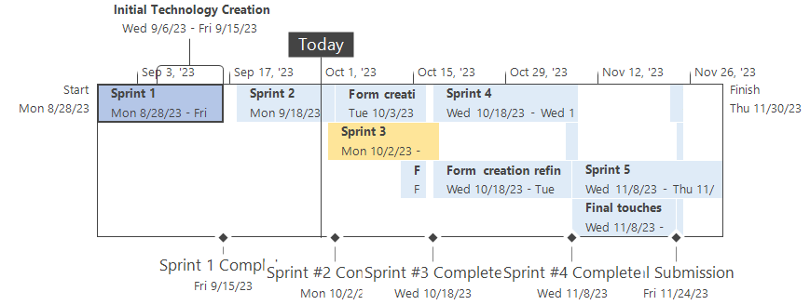

#### Figure B.2: Project Timeline Breakdown

|  |  |  |  |
| --- | --- | --- | --- |
| Task Name | Duration | Start | Finish |
| **Sprint 1** | **15 days** | **Mon 8/28/23** | **Fri 9/15/23** |
| Research and Analysis | 7 days | Mon 8/28/23 | Tue 9/5/23 |
| Initial Technology Creation | 8 days | Wed 9/6/23 | Fri 9/15/23 |
| Sprint 1 Complete | 0 days | Fri 9/15/23 | Fri 9/15/23 |
| **Sprint 2** | **11 days** | **Mon 9/18/23** | **Mon 10/2/23** |
| Homepage | 5 days | Mon 9/18/23 | Fri 9/22/23 |
| Portals | 4 days | Mon 9/25/23 | Thu 9/28/23 |
| Registration & SQL Database integration | 2 days | Fri 9/29/23 | Mon 10/2/23 |
| Sprint #2 Complete | 0 days | Mon 10/2/23 | Mon 10/2/23 |
| **Sprint 3** | **13 days?** | **Mon 10/2/23** | **Wed 10/18/23** |
| Form creation tool | 10 days | Tue 10/3/23 | Mon 10/16/23 |
| Form sharing | 2 days | Fri 10/13/23 | Mon 10/16/23 |
| Sprint #3 Complete | 0 days | Wed 10/18/23 | Wed 10/18/23 |
| **Sprint 4** | **16 days?** | **Wed 10/18/23** | **Wed 11/8/23** |
| Form creation refinement | 15 days | Wed 10/18/23 | Tue 11/7/23 |
| Final Sprint prep | 2 days | Tue 11/7/23 | Wed 11/8/23 |
| Sprint #4 Complete | 0 days | Wed 11/8/23 | Wed 11/8/23 |
| **Sprint 5** | **17 days** | **Wed 11/8/23** | **Thu 11/30/23** |
| Final touches | 12 days | Wed 11/8/23 | Thu 11/23/23 |
| Video prep | 2 days | Thu 11/23/23 | Fri 11/24/23 |
| Final Project book update | 1 day | Fri 11/24/23 | Fri 11/24/23 |
| Final showcase | 1 day | Fri 11/24/23 | Fri 11/24/23 |
| Final Submission | 0 days | Fri 11/24/23 | Fri 11/24/23 |

# Appendix C Critical Status Reports

# Appendix D Appropriate Screenshots as needed

#### Figure D.1 Homepage

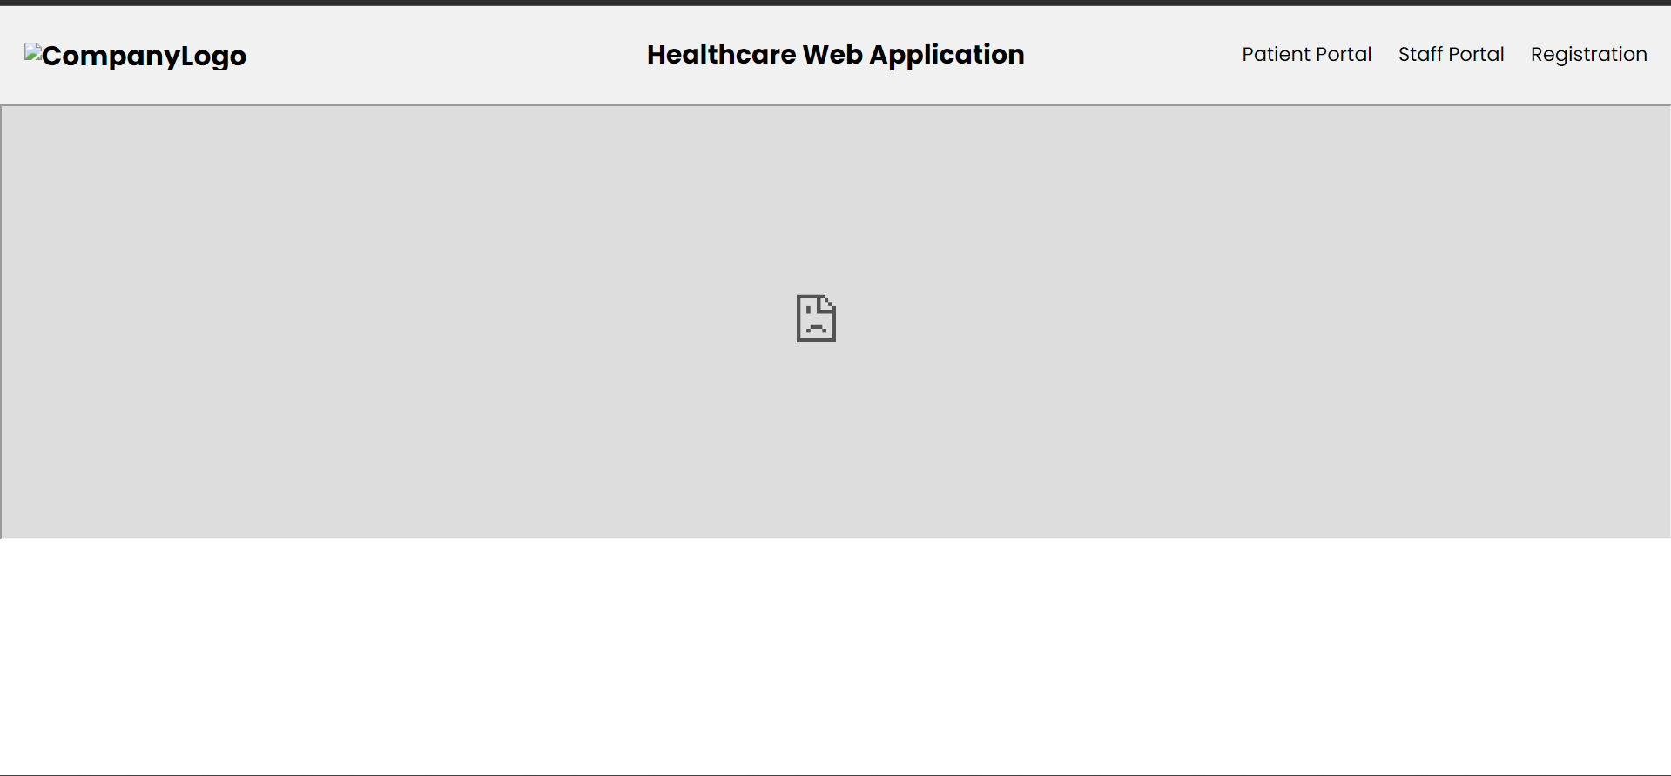

#### Figure D.2 Registration Page

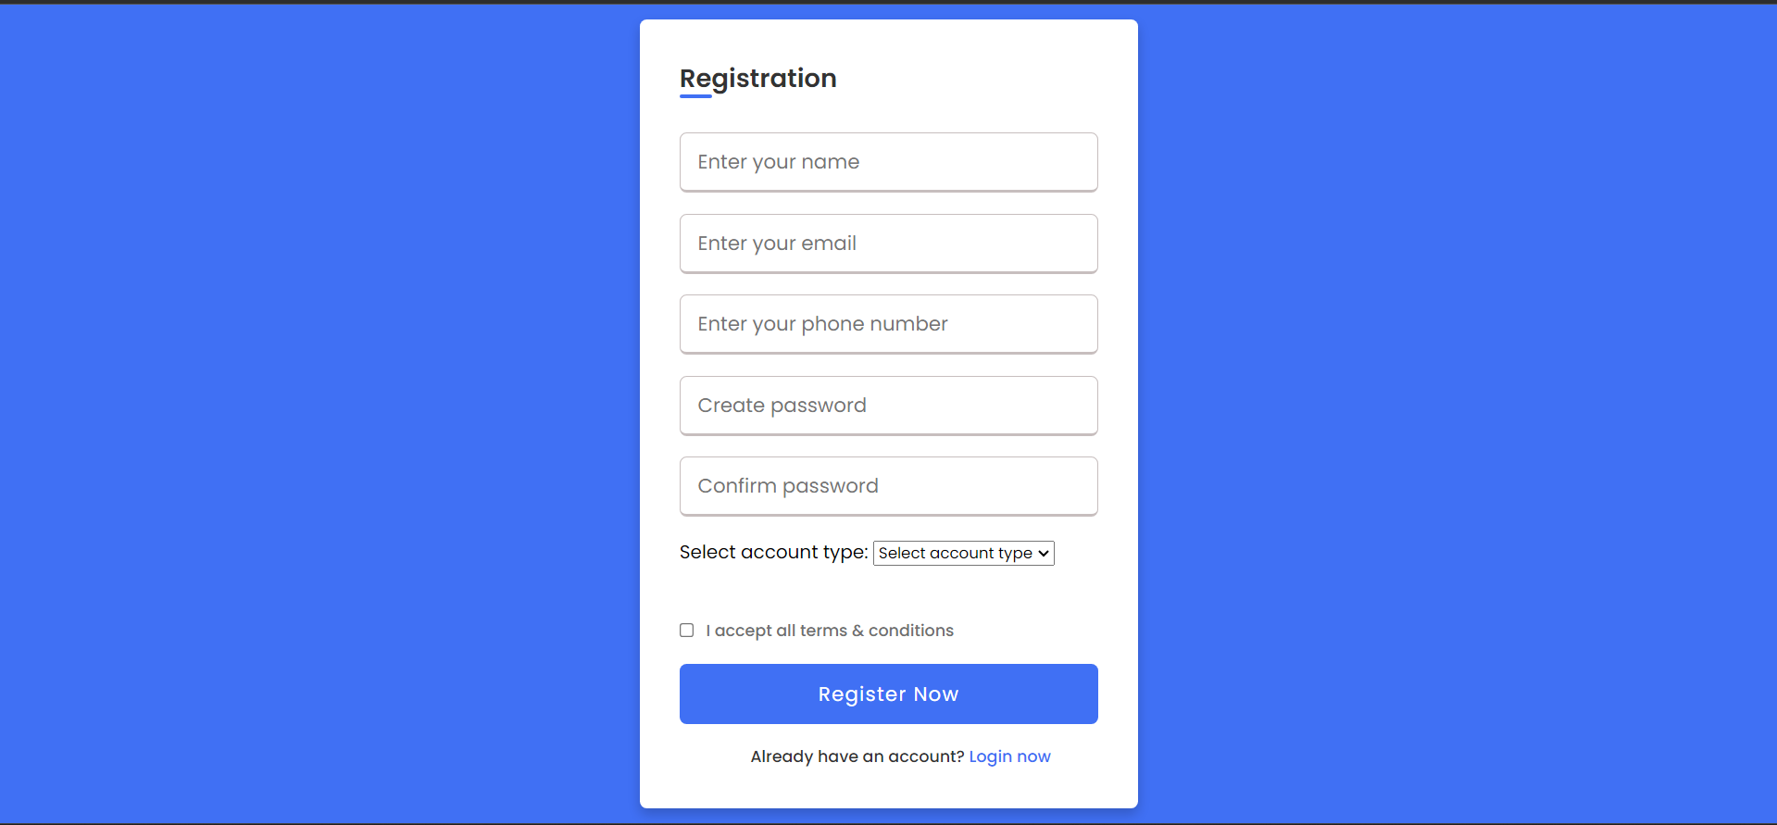

#### Figure D.3 Example SQL Connection Code

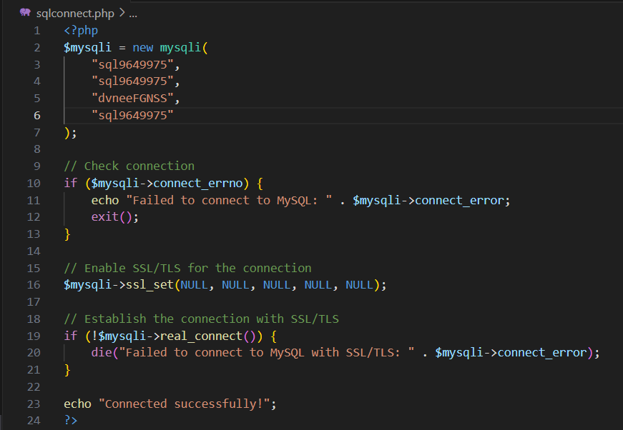

\*\**For additional files, please see the GitHub repo for this project at: https://github.com/eg3297/capstone\*\**

# Appendix D User Guide

# Appendix E E/R Diagram

# Appendix F User Stories [MoSCoW]

#### Figure F.1: User Stories

**Patient**

As a patient, I want to be able to fill out my forms before my appointment at my home. I also want to be able to see all my information and be able to see communication from my medical professionals. I do not want to have to sit in the office filling out forms while I wait, and then having to wait for my medical team to enter the information and analyze it.

**Staff**

As a staff member, I want to be able to send forms to each patient that are unique to their needs. I also want to be able to communicate with my patients and keep them updated on medications, procedures, and appointments.

#### Figure F.2: MoSCoW Analysis

**Must-Haves**

* Functional sign in portals for both staff and patients.
* Functional database connections.
* Customizable forms for staff to send to patients.
* Communication channel for staff and patients

**Should-Haves**

* Clean, user-friendly UI
* Calendar, scheduling system

**Could-Haves**

* Social media like platform
* Customizable profiles by patients
* AI Chatbot

**Won’t-Haves**

* Video calls
* VoIP capabilities

Notes on Formatting:

* You can use this template and complete/change sections as needed or create your won document.
* Feel free to add your own style through color, picture, background but be consistent!
* Use ALL the same font style throughout the document. You can change the size and add bold or coloring but use the same font!
* If you link to another document or copy and paste, be certain to update the font.
* Be certain to use level headings and update your TOC
* There should be no number on the cover page
* The TOC should be numbered i, ii, etc. In order to do this you will need Next section breaks. This document is formatted in 4 sections. 1) Cover page with no number, 2) TOC with i, ii, 3) Body of report with 1 of Total number of pages, revised date and title. You can change the footer to your own style but make certain that the “link to previous” is NOT highlighted. Other formatting that is to apply only to one section…Apply to “This section” in the Layout tab
* Revised: Date in footer should update automatically. You can copy and paste the footers from this document into your document.