Dalton Grimes
CIT 273 Midterm

Title of Project: 5th Grade Student Website

Target Audience: This website targets 5th grade students

Purpose of Website: The purpose of this website is to give an “About Me” that outlines my major, skills, and hobbies. The website has a link to play the classic game “Snake” and contains 2 other pages targeted at 5th grade students. The 2 pages are math and science related. The math page is a lesson on adding, subtracting, and multiplying decimals. The science page is about bodies of water and how freshwater and saltwater interact with each other.

Site Map:
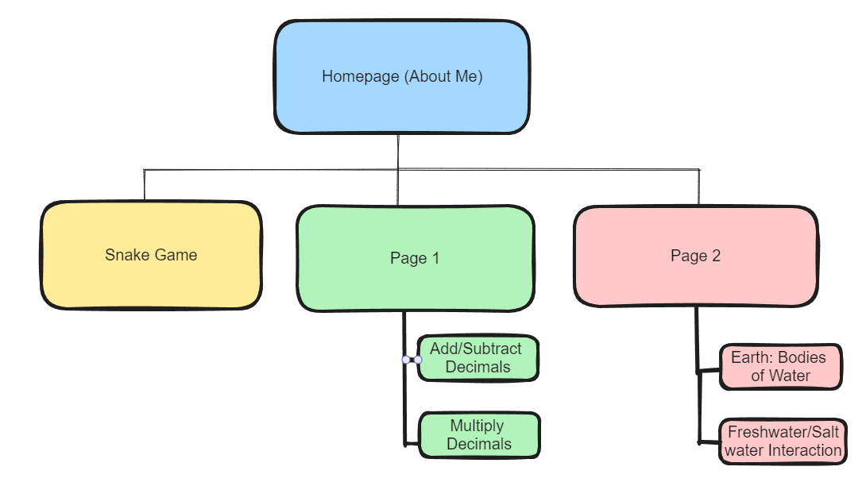

Wireframe:
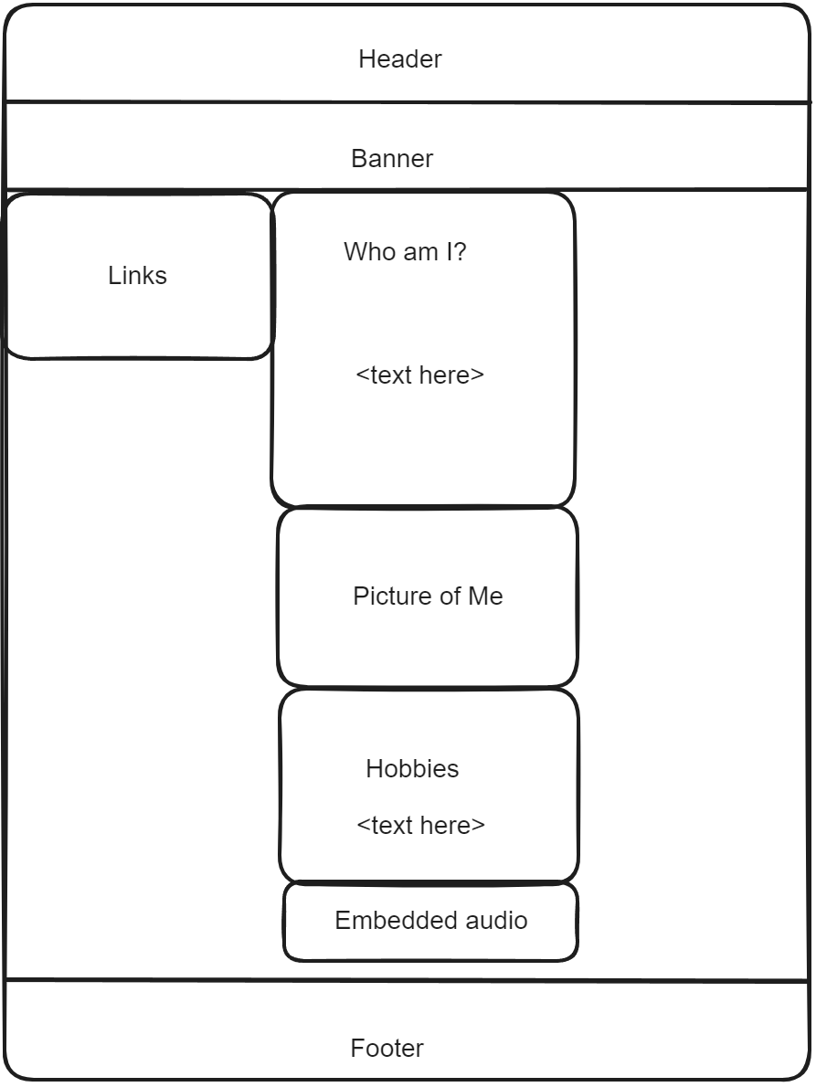 About Me page
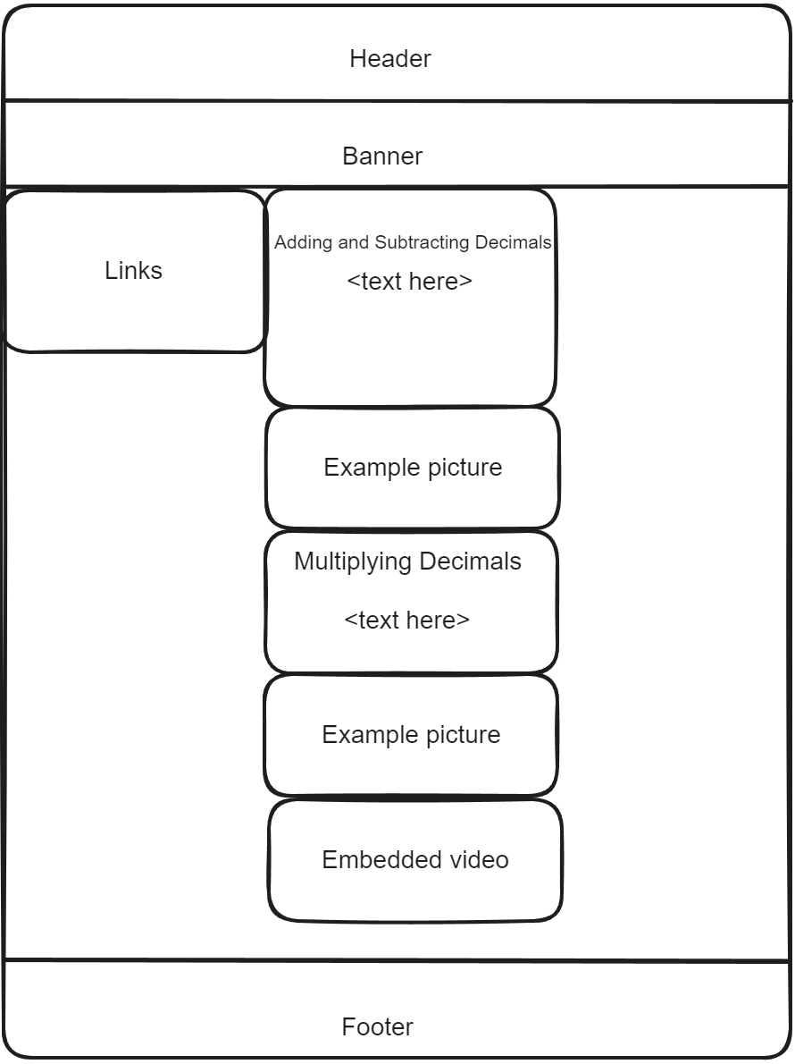 Page 1 (Math Lesson)
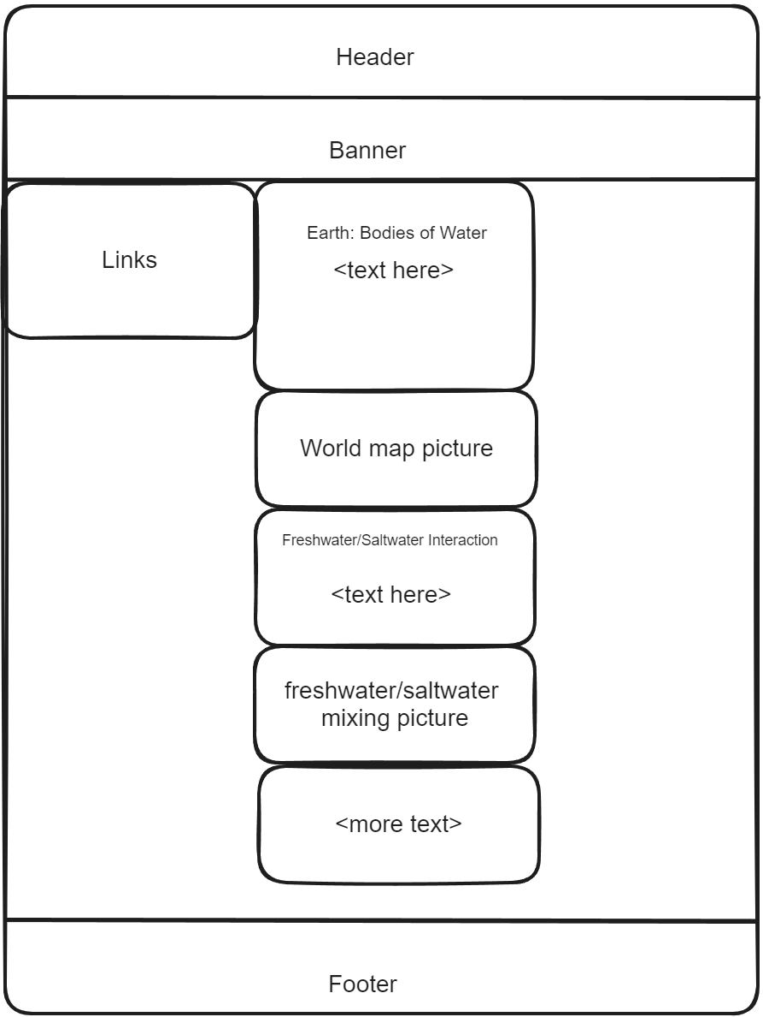 Page 2 (Science Lesson

