Keith Hibbard
Dr. Snyder
PHY 101

Activity 1: Series DC circuit with two light bulbs.
- Build a Series Circuit with two light bulbs and one 9V battery.
- Take a screenshot of your lab set up.
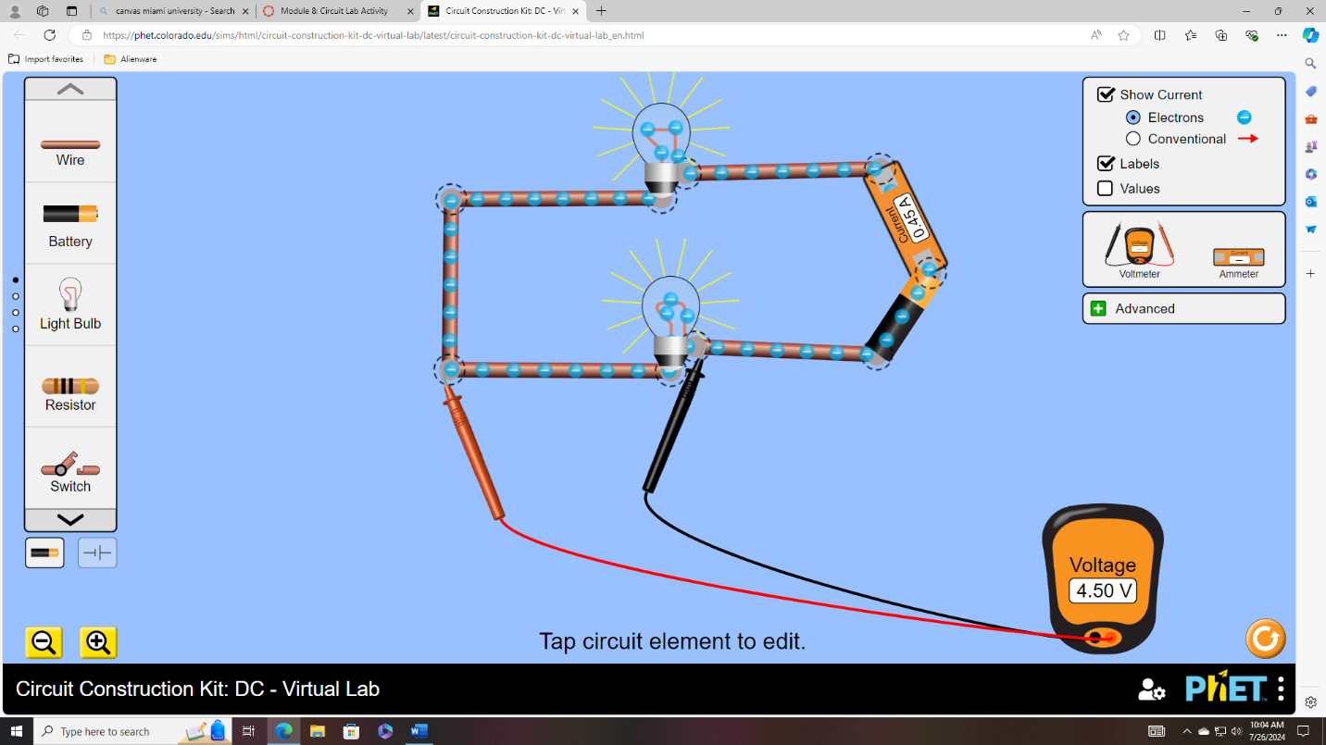
- Answer the following questions:
  - What is the total voltage of the circuit? The total voltage of the circuit is the same as the battery so it is 9V.
  - What is the voltage for Light Bulb 1 and Light Bulb 2? Each of the light bulbs have a voltage of 4.5V.
  - What is the Current in the Wire? The current in the wire is .45 Amps

Activity 2: Parallel DC Circuit with two light bulbs.
- Build a Parallel Circuit with two light bulbs and one 9V battery.
- Take a screenshot of your lab set up.
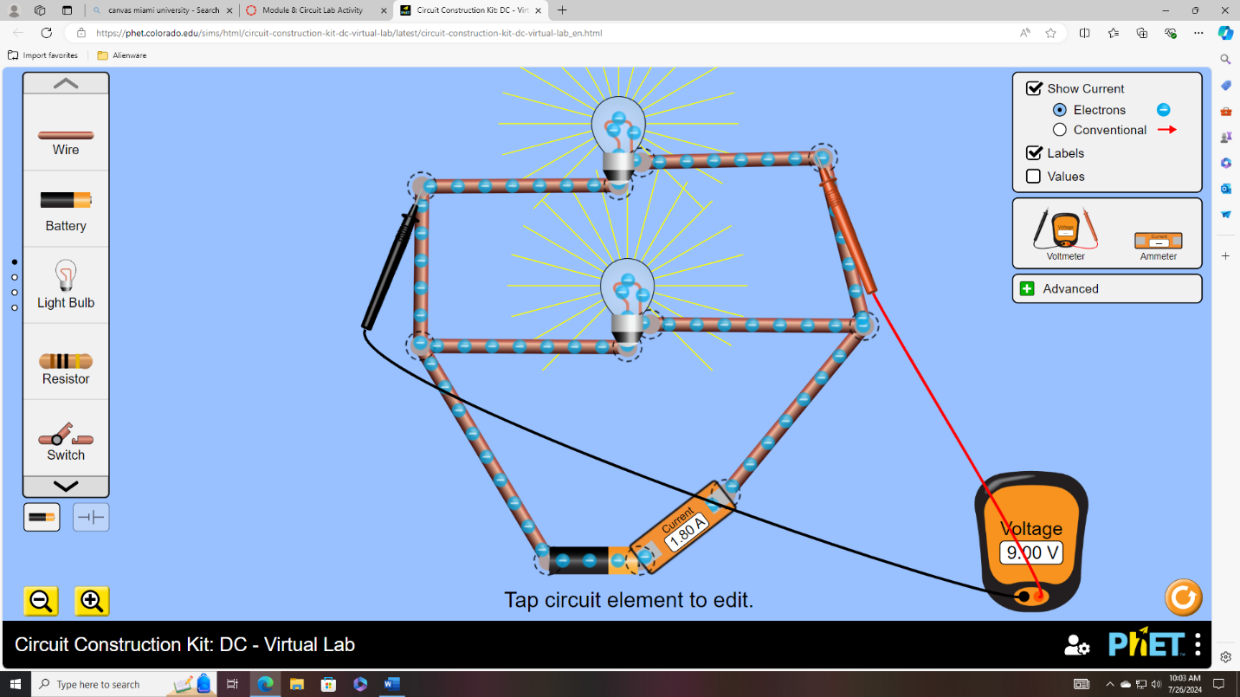
- Answer the following questions:
  - What is the total voltage of the circuit? The total voltage of the circuit is 9V.
  - What is the voltage for Light Bulb 1 and Light Bulb 2? Each of the light bulbs has a voltage of 9V.
  - What is the Current in the Wire? The current in the wire is 1.8 Amps

