Keith Hibbard
Professor Gramann
CSE 163

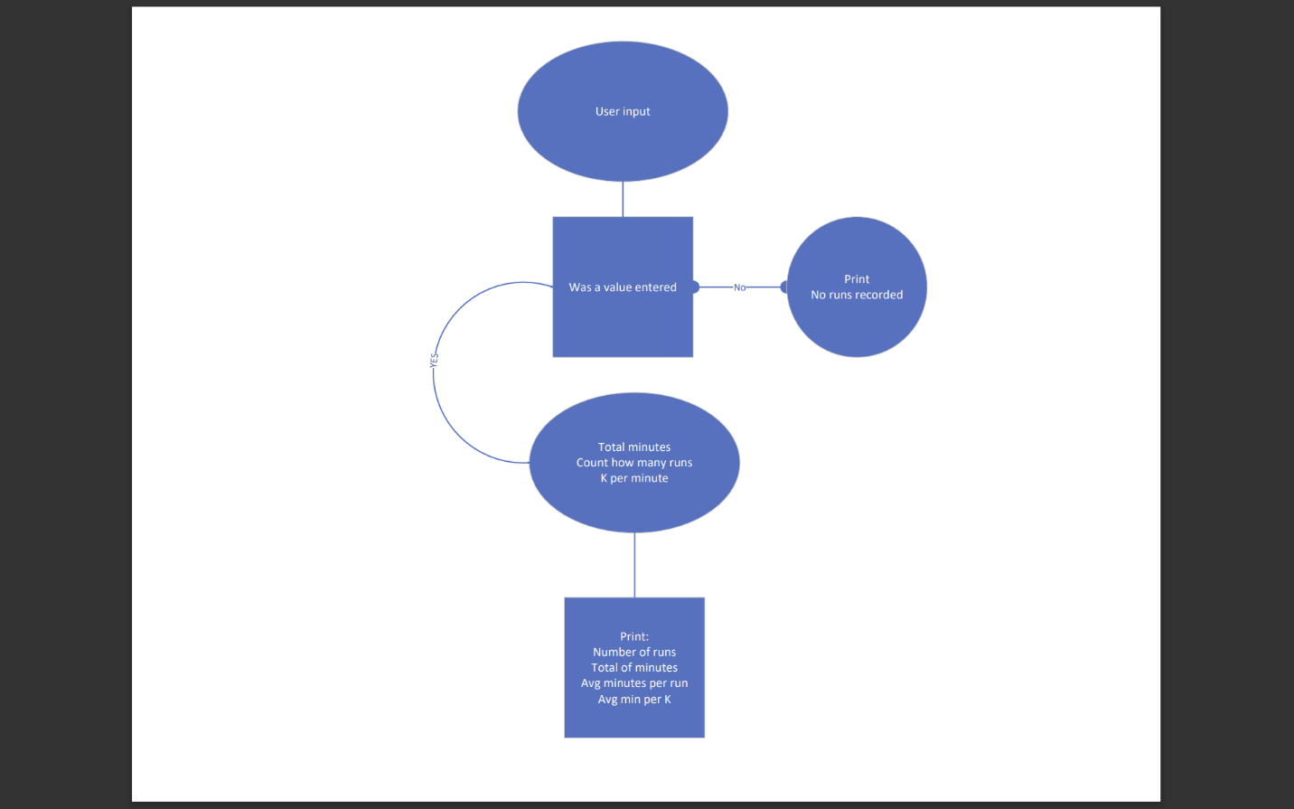

Pseudo code
Enter minutes ran
If no value entered
Print No runs recorded
Else value entered, accept another entry
If no additional values entered
Print number of runs, total of minutes, avg mins per run, avg min per Kilometer

Test Run 1
Enter the number of minutes ran (or press Enter to finish):
10
10
20
20
5
Number of runs: 5
Total minutes: 65
Average minutes per run: 13.00
Average minutes per kilometer: 2.60

Test Run 2

Test Run 1
Enter the number of minutes ran (or press Enter to finish):
5
6
7
8
Number of runs: 4
Total minutes: 26
Average minutes per run: 6.50
Average minutes per kilometer: 1.30

My program works as expected because of testing. Results calculated and displayed correctly.

# Variables for runs and minutes
count = 0
total_minutes = 0

# WHILE loop for input
while True:
# input of minutes ran
user_input = input("Enter the number of minutes ran (or press Enter to finish): ")

# IF statement to see if a value was inputed
if user_input == "":
break # Loop end if no minutes are entered

# minutes are intergers and not float
minutes = int(user_input)
total_minutes += minutes

# How many runs
count += 1

# IF statement to ensure more than zero input and ELSE statement if none entered
if count > 0:
# Average minutes per run
average_minutes_per_run = total_minutes / count

# Average kilometers per minute (assuming 5 minutes per kilometer)
average_kilometers_per_minute = average_minutes_per_run / 5

# Output of calculations
print(f"Number of runs: {count}")
print(f"Total minutes: {total_minutes}")
print(f"Average minutes per run: {average_minutes_per_run:.2f}")
print(f"Average minutes per kilometer: {average_kilometers_per_minute:.2f}")
else:
print("No runs were recorded.")

