Keith Hibbard
Professor Bundy
ENG111
4/7/24

The most persuasive argument for learning how to utilize multimodal composition is because this is a skill that I may be called to use in future classes/assignments. As we’ve worked through our assignments in this course, I’ve learned how to use elements such as rhetoric in my compositions. I enjoy reading an essay if the topic is something that interests me. I feel that a great way to pique interest in a reader could be accomplished from multimodal communication with the use of webpages, posters, etc… These items may spark an interest and allow the audience to “feel” a draw toward a subject.
Because I am not very involved with social media I find the Instagram example the least persuasive argument. I do understand the impact of photos and the desire some feel to share with others. I view social media as more of a current generational trend and I am less active and/or comfortable using it. I just don’t feel as motivated to utilize multimodal communication in that way.

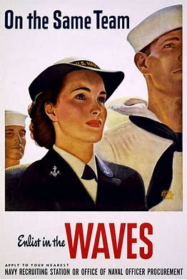
https://live.staticflickr.com/4016/4359103566_cd6ef977ed.jpg

In the WW2 Navy recruiting poster, “On the same team: Enlist in the WAVES, U.S. Navy poster, 1943” there are several modes represented. The first thing I notice is the gestural mode. The female in a Navy uniform posing proudly beside males in Navy uniforms. Her face displays confidence and she is smiling. This image conveys to an audience a sense of her pride and her understanding that she belongs alongside the male sailors.

The second mode I notice is the spatial mode. The word “WAVES” is in larger font and in red (the same red as the female’s lipstick). Red appeals to an audience because red is a passionate color and is also the color associated with the medical field. The Waves were the women’s reserve units of the Navy that provided emergency medical service. The use of red, and the size of the font persuades an audience to understand the job and the big importance of the job.

And finally, the linguistic mode is used as the text of the poster calls to the audience to be on the same team as male sailors. There is an equality in that statement that persuades a reader to consider choosing to enlist because of the opportunity to act during wartime vs. feeling excluded because they are a woman.

Because a multimodal approach is more than an essay the opportunity exists to broaden the audience. The most crucial step in composing my remediation project is considering the audience. A visual appeal element using multimodal composition gives me the chance to develop an audience outside the confines of an essay. If I am mindful of the audience that I want to attract I can use that influence to help me develop my composition.
Gagich mentions the author as a consideration and how bias can creep into a message. I agree with Gagich that an author must be aware of how biases can influence the message. I also feel that an author’s bias is how a message creates depth. If the author is more concerned about not showing bias is the author being their true self? I prefer to read from a strong perspective more so than a wishy-washy author so an author’s bias is something I would like to be able to pick out in the message. Although I have not used multimodal texts for assignments in the past, I feel I understand the abilities of this method of communication, and I have ideas on how I would like to approach this assignment.

