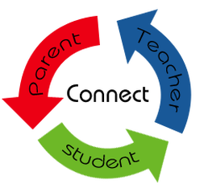

https://www.unconditionaleducation.org/blog/archives/03-2018



http://alabamaschoolconnection.org/2013/08/27/how-to-start-a-meaningful-partnership-with-your-childs-teacher/

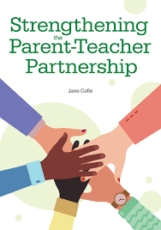
https://www.responsiveclassroom.org/product/strengthening-the-parent-teacher-partnership/



https:// www.smcschool.com/the-messenger/christian-parent-christian-school-a-powerful-partnership-for-children

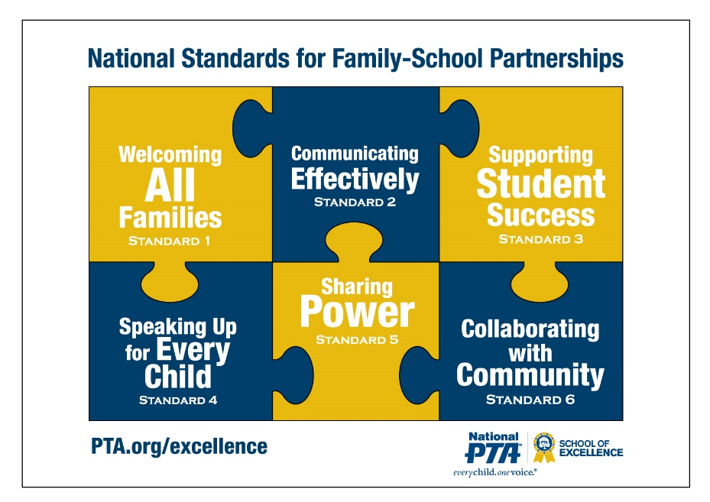

Family-School Partnerships – Massachusetts PTA



Parent partnerships | Nadeen School

