Final Project plan
- Topic/Theme: shopping cart user account
- Description: Overall(Theme/Description): This project will be an example of people “purchasing” items with logins and passwords, being able to see what they bought and allowing admins to change certain topics. There will be 4 main pages in order to complete this index.php, About.php, mywork.php and contact.php
Login process
- Register.php new account page for new users
- Login page will have normal and admin users
- CSS plan – at least 2 files, one for banners and other for general page making
  - Only admins can use CRUD items from tables
  - All members will show under the mywork.php page
- Web site map
Index.php (home)
- Correct logins will make a shopping cart member
- Incorrect logins will not be added to cart members
Contact.php
Mywork.php
About.php

4. Database plan
Titles properties
UserID INT(25) NOT NULL AUTO_INCREMENT PRIMARY KEY
Username VARCHAR(65) NOT NULL
Password VARCHAR(32) NOT NULL
Email Address VARCHAR(255) NOT NULL
Table for shopping cart
Title properties
Item_id INT(25) NOT NULL AUTO_INCREMENT PRIMARY KEY
Description VARCHAR(65) NOT NULL
Price decimal(8,2) NOT NULL

5. PHP plan
- four web pages
- register and login will user useraccount business logic for login purposes
- member only page – mywork.php shows only logged in members
- admins can modify items for the shopping list
6. form plan and overall GUI design

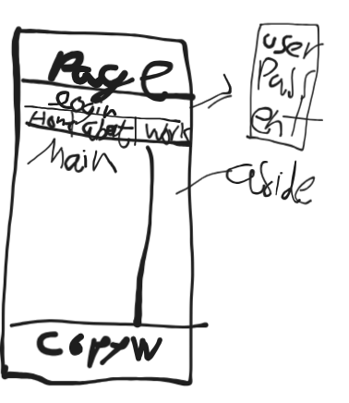
7. other
Css – using two css files for banner and responsiveness and will be labeled accordingly

