Title – midterm project
Target audience – 4th grade addition and subtraction
Purpose of website – to teach 4th graders addition and subtraction addition and subtraction will be separated into the two website
Site map –
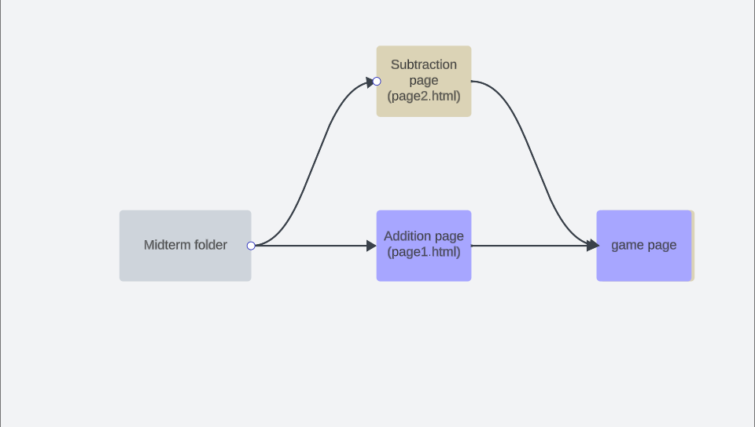

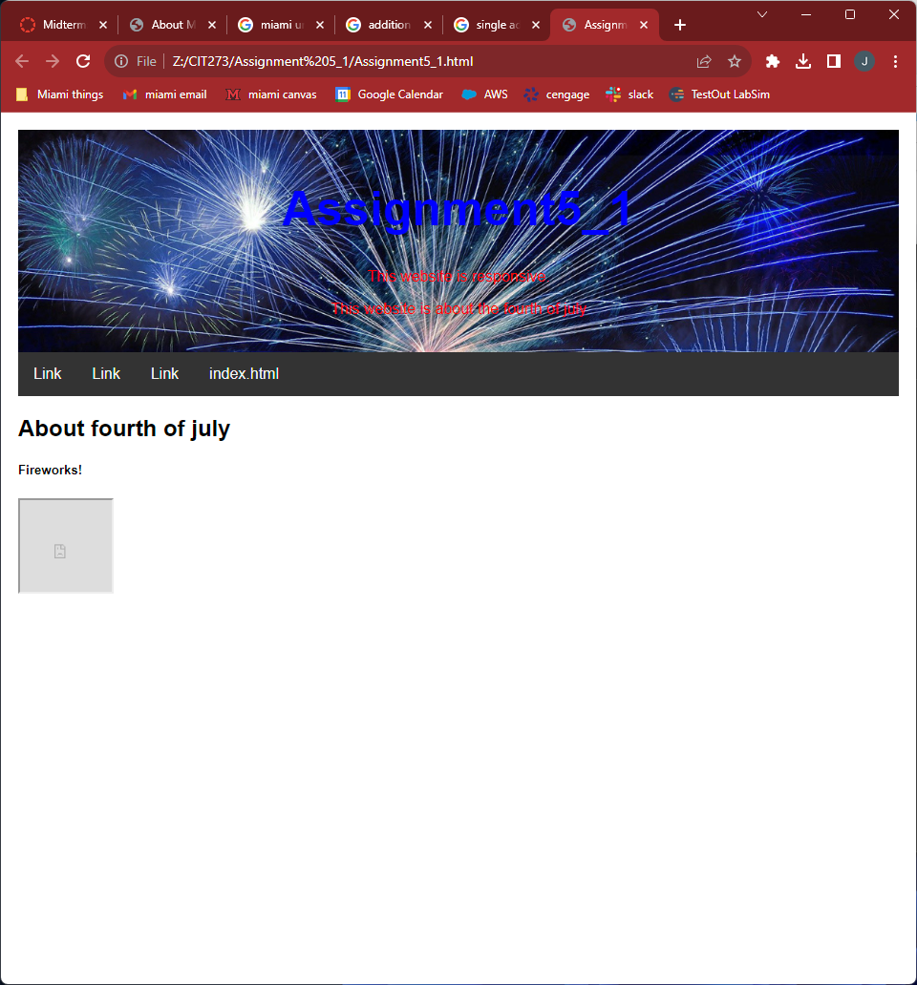
Using this as a template will be a good start for this project.

