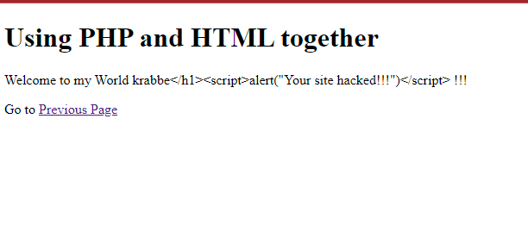
http://cit-web.regionals.miamioh.edu/users/krabbejx/CIT273/Module9_3_1/

