Brian Lampkin

1. Theme- Create a website where you can shop and buy various products.
2. The user will be able to login. Add and delete items from their carts. The user will also be able to contact the owner of the website and give ideas. The website will be easy to use and easy to navigate through. The main website will be index.php, my_work.php, contact.php, about.php. The products will be sports related.
3. I attempted to download a site map creator and was unsuccessful.

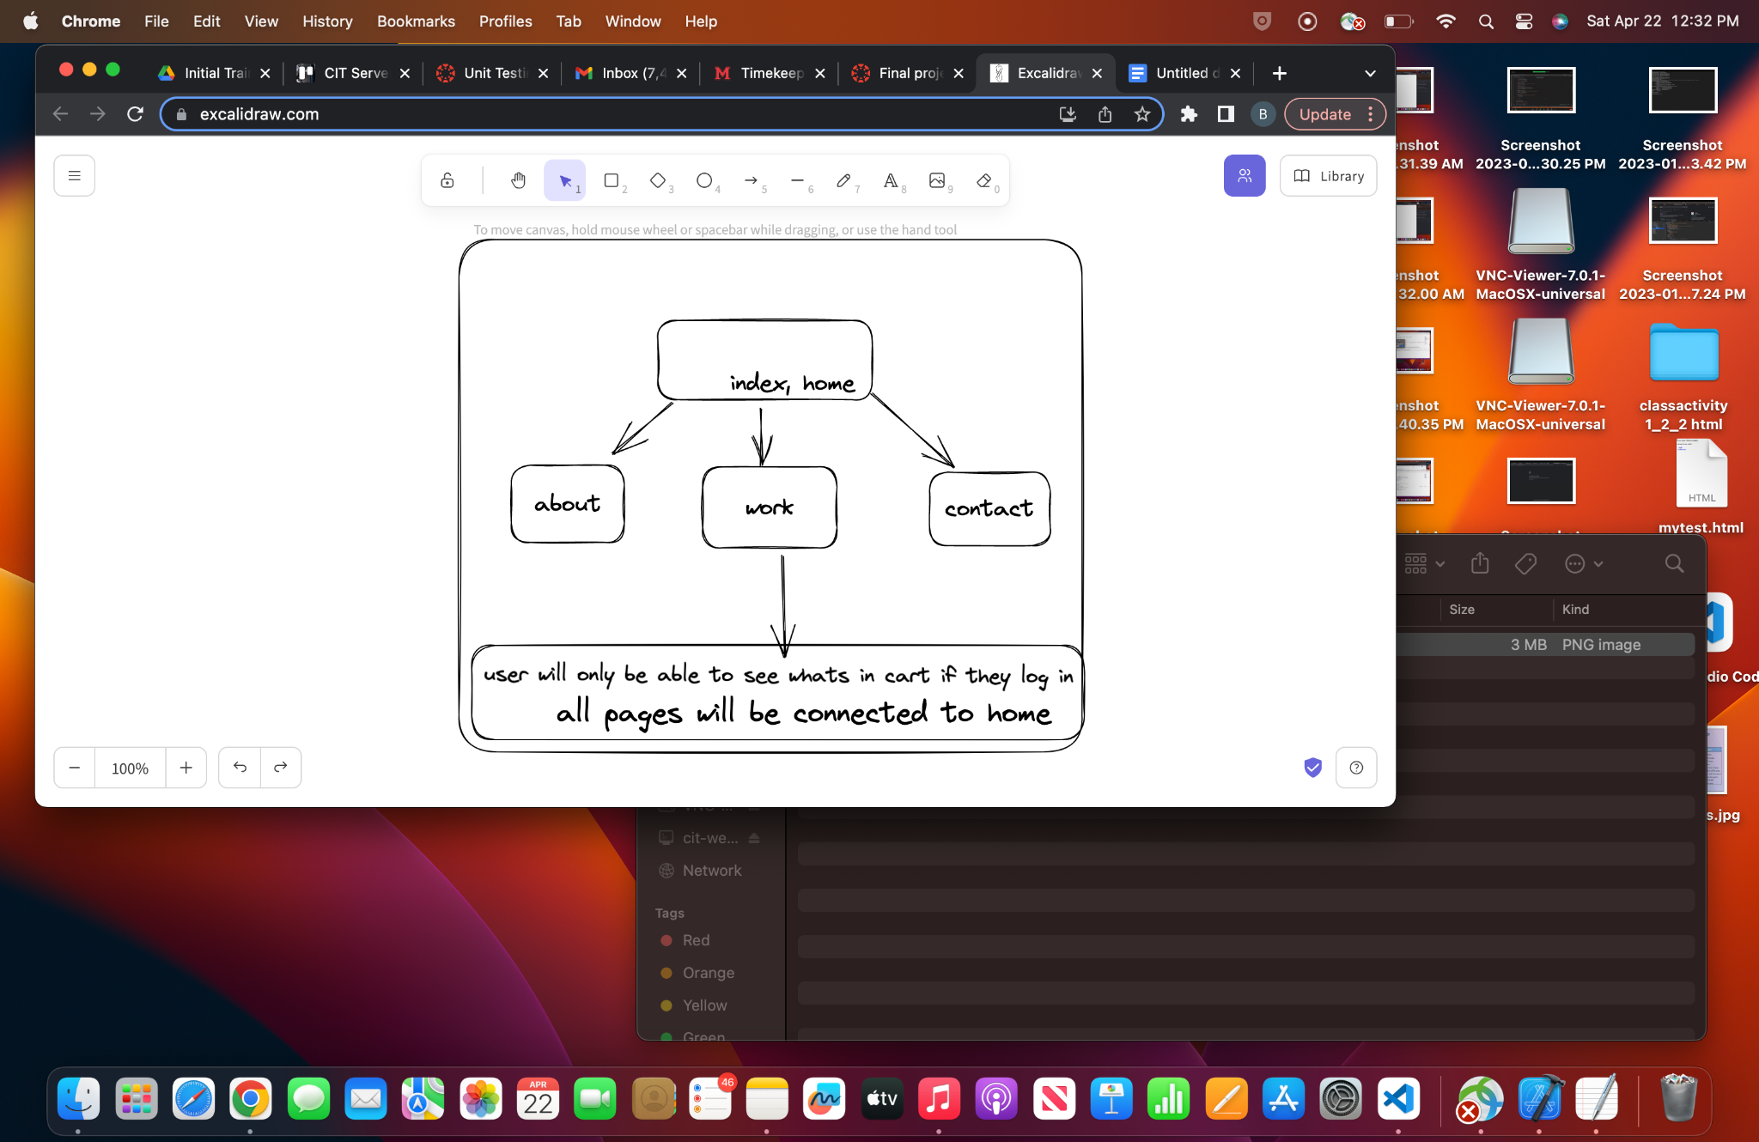

4)

| userID | INT25 |
| --- | --- |
| Username | Var65 |
| password | Var65 |
| email | Var65 |
| item | Var65 |
| price | Var65 |

5) I will use base.php, and image.php.

6) I will be using Index.php. My_work.php,about.php, and contact.php. Index.php will be the homepage where u can see everything available. You will also be able to sign in with email and password and once you do that if you click My_work.php then u will see everything in your cart and be able to make a purchase.

7)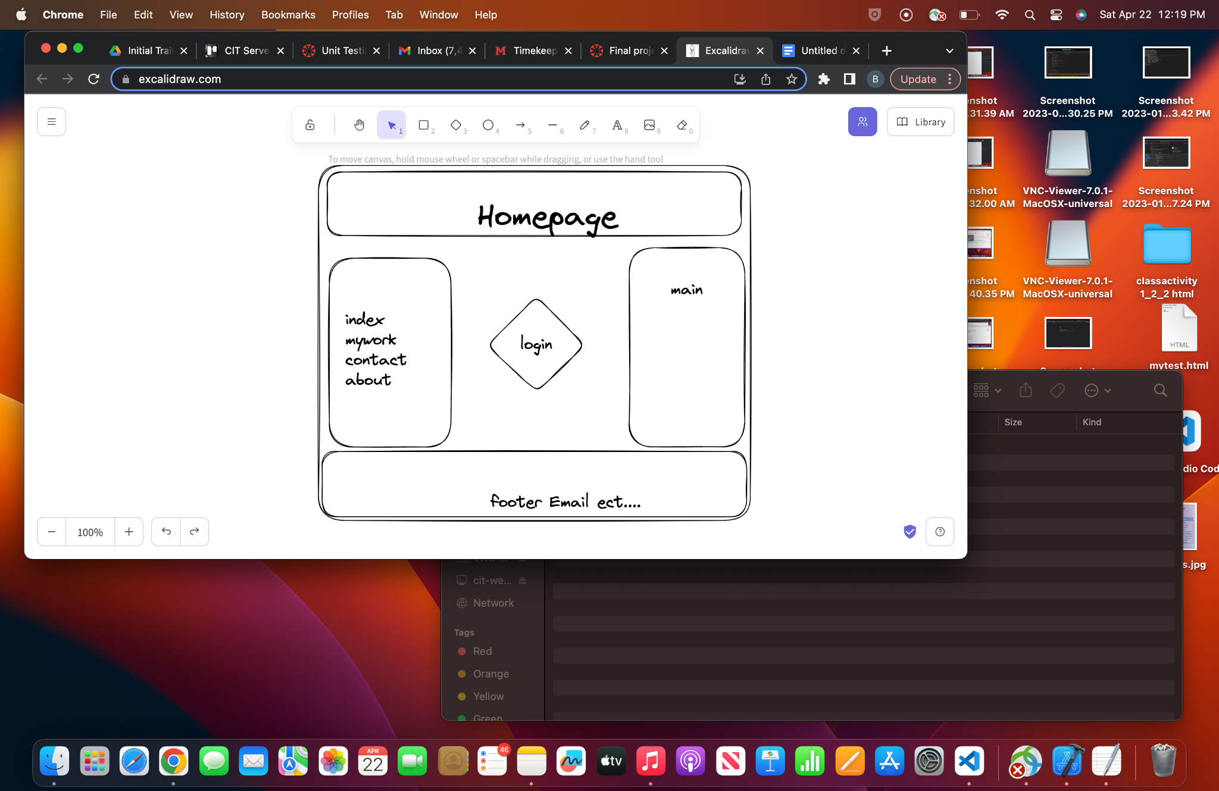

Will possibly change this up. I like having the login right in the middle so it makes it easy for users to login. And to the right they will see whats available, to the left will be the different tabs. And at the bottom will consist of my email and the year.