Midterm Project Plan

* Page 1:
  + 3rd Grade English Website
    - Audience: Third Grade Students
  + Purpose: This website will feature a short story about the three little pigs and the big bad wolf. The page will also feature a video version of the story as well as an audio version. The page will focus on a short story since there is no need for overcomplication on a third-grade website.
  + Design:
    - 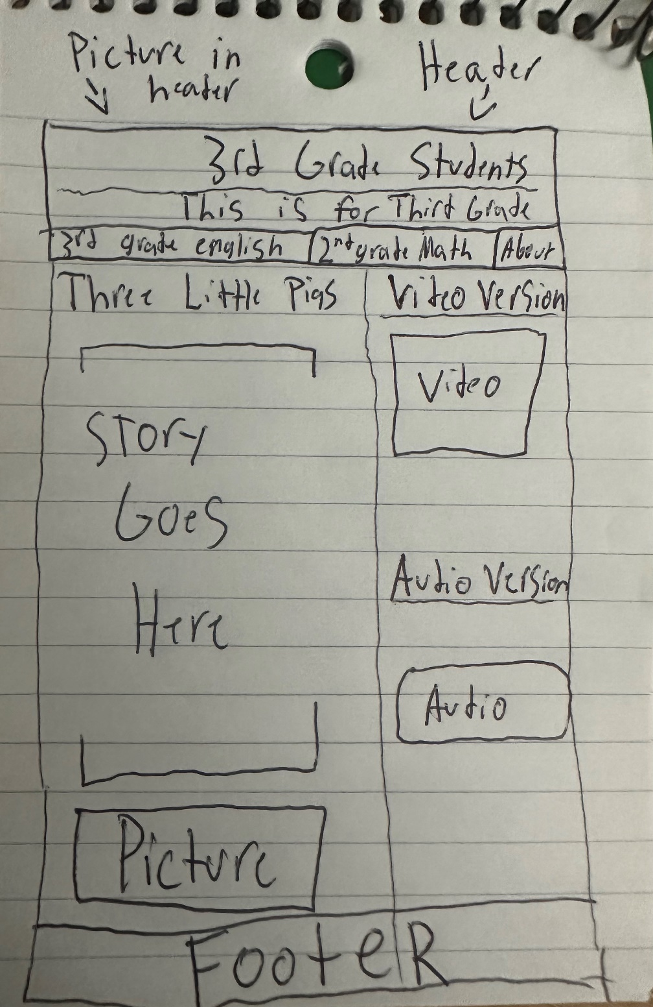
* Page 2:
  + 2nd Grade Math Website
    - Audience: Second Grade Students
  + Purpose: This website will feature a short description of what the second-grade math curriculum will feature. The website will also detail the desired outcomes of the course. On the right-hand side, there will be a photo showing the student’s second-grade math goals.
  + Design:
    - 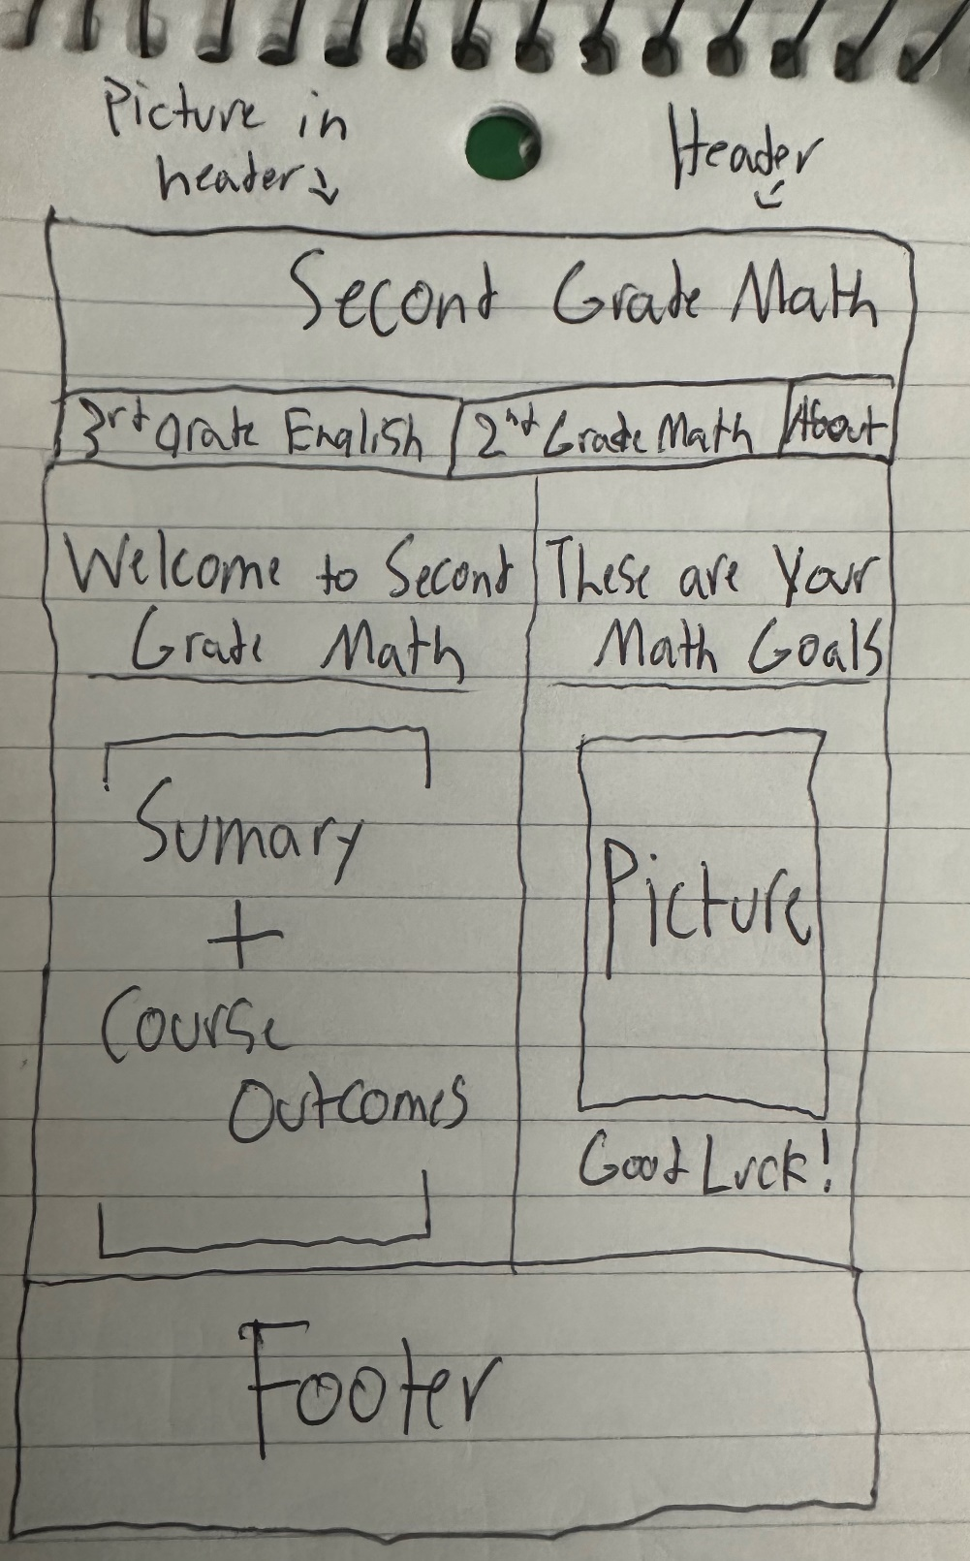
* Page 3:
  + About Me
    - Audience: Future Employers
  + Purpose: This website will feature a short summary of myself and what I have been studying. The summary will also include my skills as well. Below the summary, a detailed list of courses I have taken will also be presented. On the right-hand side, there will be an “Employment History” section that explains my past internship and what I was required to do at the job.
  + Design
    - A piece of paper with writing on it

      Description automatically generated