Xander Simpson
Professor Dr. Deepak Dawar
Class Activity_1_1_1
Sunday, February 2, 2025

PING
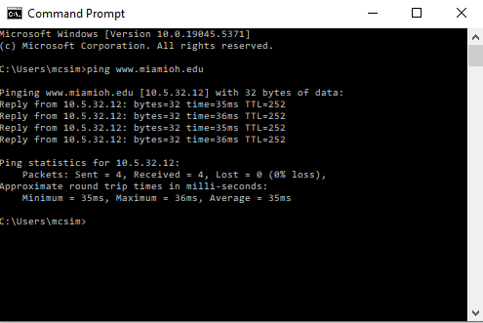
IPCONFIG/ALL
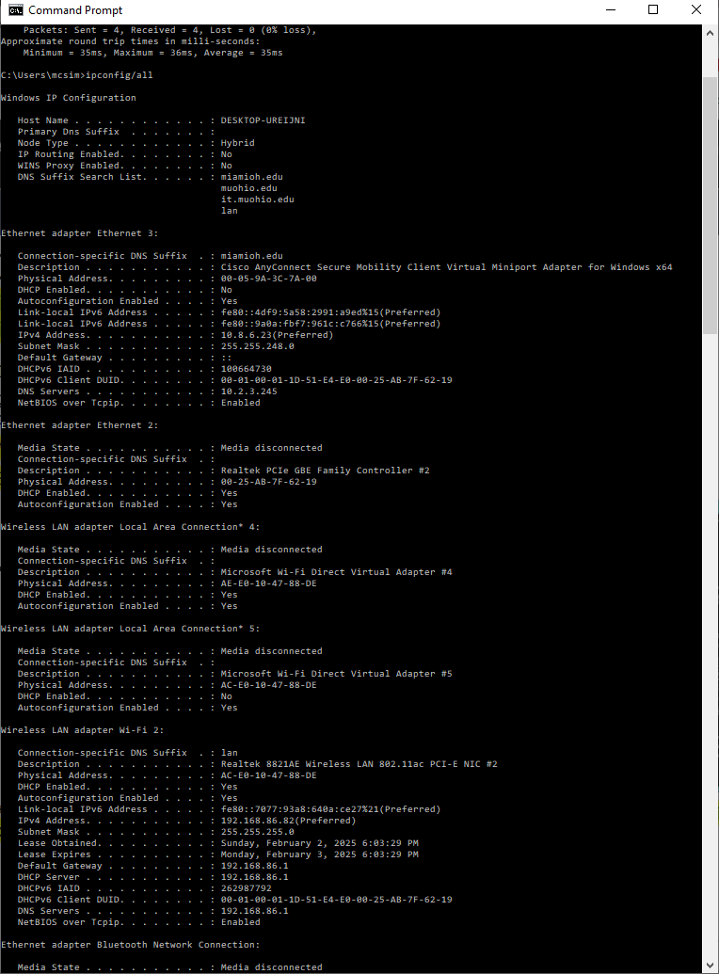
Miami IP-10.5.32.12(entered and got the Miami.edu site)
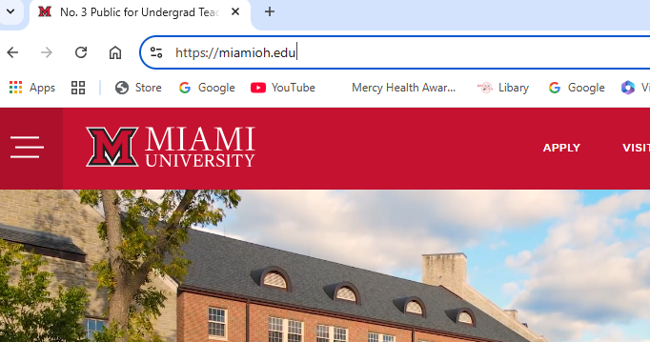
NSLookup-Capture
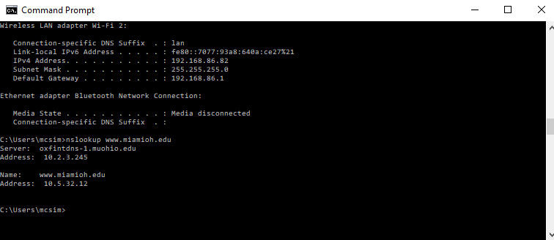
View Page Source-Capture
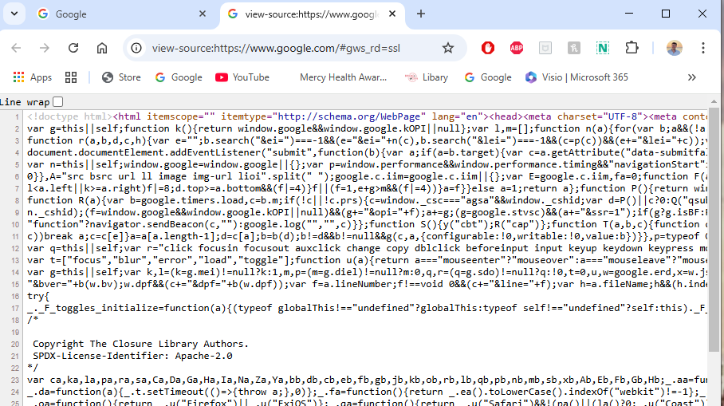
HTTP Viewer-capture
