Xander Simpson
Professor Dr. Deepak Dawar
Class Activity_1_2_2
Sunday, February 2, 2025
Markup Validation Service
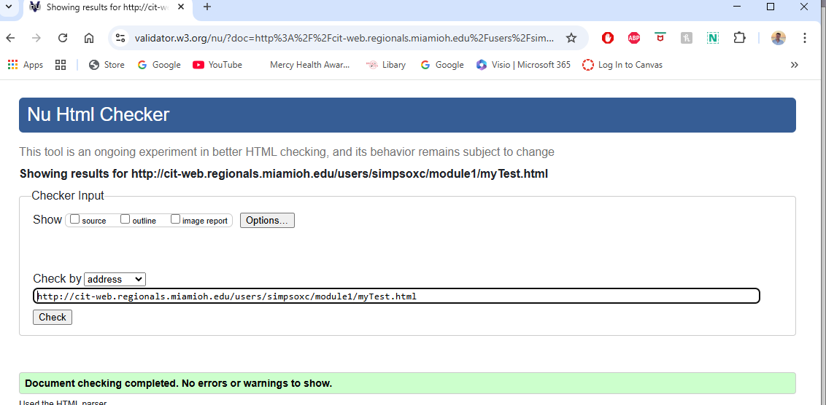
W3C CSS Validator
