Xander C. Simpson
Professor Dr. Dewar
Class Activity-2-3
Sunday, February 9, 2025
Old
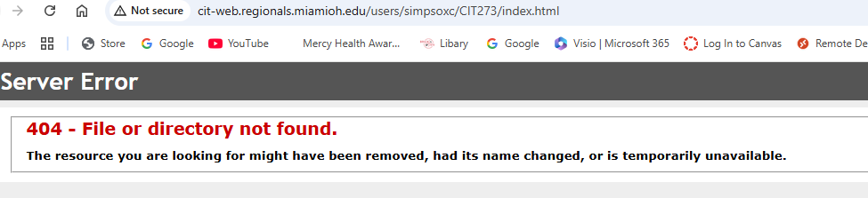
New
