MidtermPlan
About Me This is the URL to the website
Title of the Project
3rd Grade Science Explorers
An engaging, multimedia-rich educational website for young learners.
Target Audience
3rd Grade Students (ages 8–9)
Curious learners interested in space, animals, and interactive science content.
Purpose of the Website
To introduce 3rd grade students to science topics like the Solar System and Animal Habitats using videos, music, images, and interactive games. The site is designed to be fun, accessible, and educational, supporting classroom learning and independent exploration.
Site Map (Visual Sitemap)
You can insert a simple visual like this using Word’s SmartArt or draw it manually:
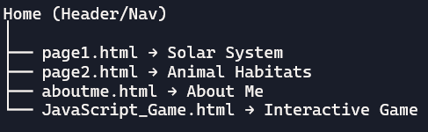
page1.html – Solar System
- Header: Banner image + site title
- Nav: Links to all pages
- Aside: “Explore space and planets!”
- Main:
  - Title: “Learn About the Solar System”
  - Image of planets
  - Embedded YouTube video
  - List of planets
  - Fun fact
- Footer: Copyright
page2.html – Animal Habitats
- Header: Same banner and title
- Nav: Same links
- Aside: “Discover where animals live!”
- Main:
  - Title: “Explore Animal Habitats”
  - Image of Habitats
  - Audio clip (jungle sounds)
  - List of habitat types Fun fact
- Footer: Copyright
aboutme.html – About Me
- Header: Same banner and title
- Nav: Same links
- Aside: “Meet the creator!”
- Main:
  - Personal intro
  - Skills and goals
  - Why this site matters
- Footer: Copyright

